Message from the President

The GLANC group ended 2023 on a great note, with our monthly Day Tours back on track, and finding new ways to get out into the community and connect with others. Our scholarship program is going strong, as we continue to support youth in the arts more than ever. We are also looking for more opportunities to branch out into the community, and draw new people into the exciting world of glass.

On that note, collaboration with other organizations can be a critical way to accomplish this, and we are excited to announce that we have a confirmed location for a GLANC artist member exhibition and sale! We have an excellent location lined up at the Piedmont Art Center, on June 22 & 23. Anyone who is a GLANC member artist can participate. Our member artists are diverse and our sponsorship of this space will be a great way to not only support their careers, but also expose the broader to community to the wide array of creativity going in the glass art space. We see potential for this to become an annual event, which can be instrumental in really raising the visibility of the glass arts in the Bay Area.

We have been busy planning activities for the rest of the year, so be sure to save the date for the events already on our calendar. We have an exciting year ahead!! All the best to everyone for a healthy, happy and glass-filled 2024!!

Best,
Demetra Theofanous
President, Glass Alliance of Northern California

Welcome to our New Members!

Julie Orchard, Leilee Weyerhauser,
Aimee Cohen

SAVE THE DATE!
Upcoming GLANC events

March 2: Natalya Burd at Minnesota
Street Project

March 30: Tour of the Garfinkle
collection

April: Steve Parcher Studio

May: Oben Abright demonstration at
Public Glass

June 22&23: GLANC Artist Sale
Piedmont Art Center

July: SF Museum of Craft + Design

GLANC Newsletter Staff:
Editor: Demetra Theofanous

Contributors to this Issue:
Demetra Theofanous

DAY TOUR REPORTER NEEDED

GLANC is still looking for a new newsletter writer for our Day Tours! This will be our last newsletter unless we find a volunteer to attend all of GLANC's monthly Day Tours, and write about them. We hope to find a volunteer, otherwise GLANC will have to discontinue this quarterly benefit for our members. This is a volunteer position. If anyone is interested, please contact glanc@comcast.net .

GLANC DAY TOUR - Marvin Lipofsky Studio and Sale
[Demetra Theofanous]

GLANC had a unique opportunity recently to visit Marvin Lipofsky Studio. Jeanette Bokhour was so generous with her time and energy in prepping a very special viewing and sale for our group! It was an absolute treasure trove of collectibles, and there was so much to see (and buy!), we ended up scheduling an encore date for those that couldn't make it the first time, or simply wanted to go again!

As a teacher at CCA, Marvin acquired a number of unique pieces from visiting artists, as well as many unique collectibles from his travels. Of course there were also many stunning pieces created by Marvinn himself! Thank you Jeanette for an amazing day!!

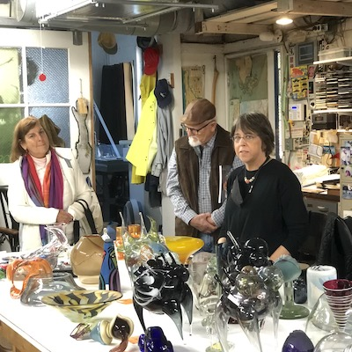
Jeanette Bokhour and GLANC members

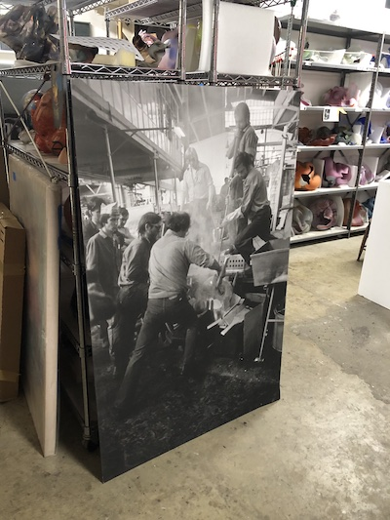
Amazing vintage poster with Marvin Lipofsky

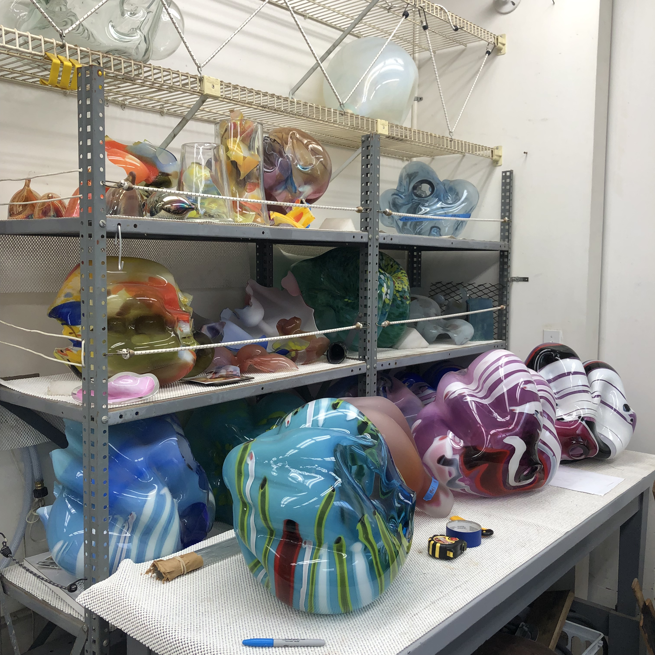
Incredible array of sculptures by Marvin Lipofsky
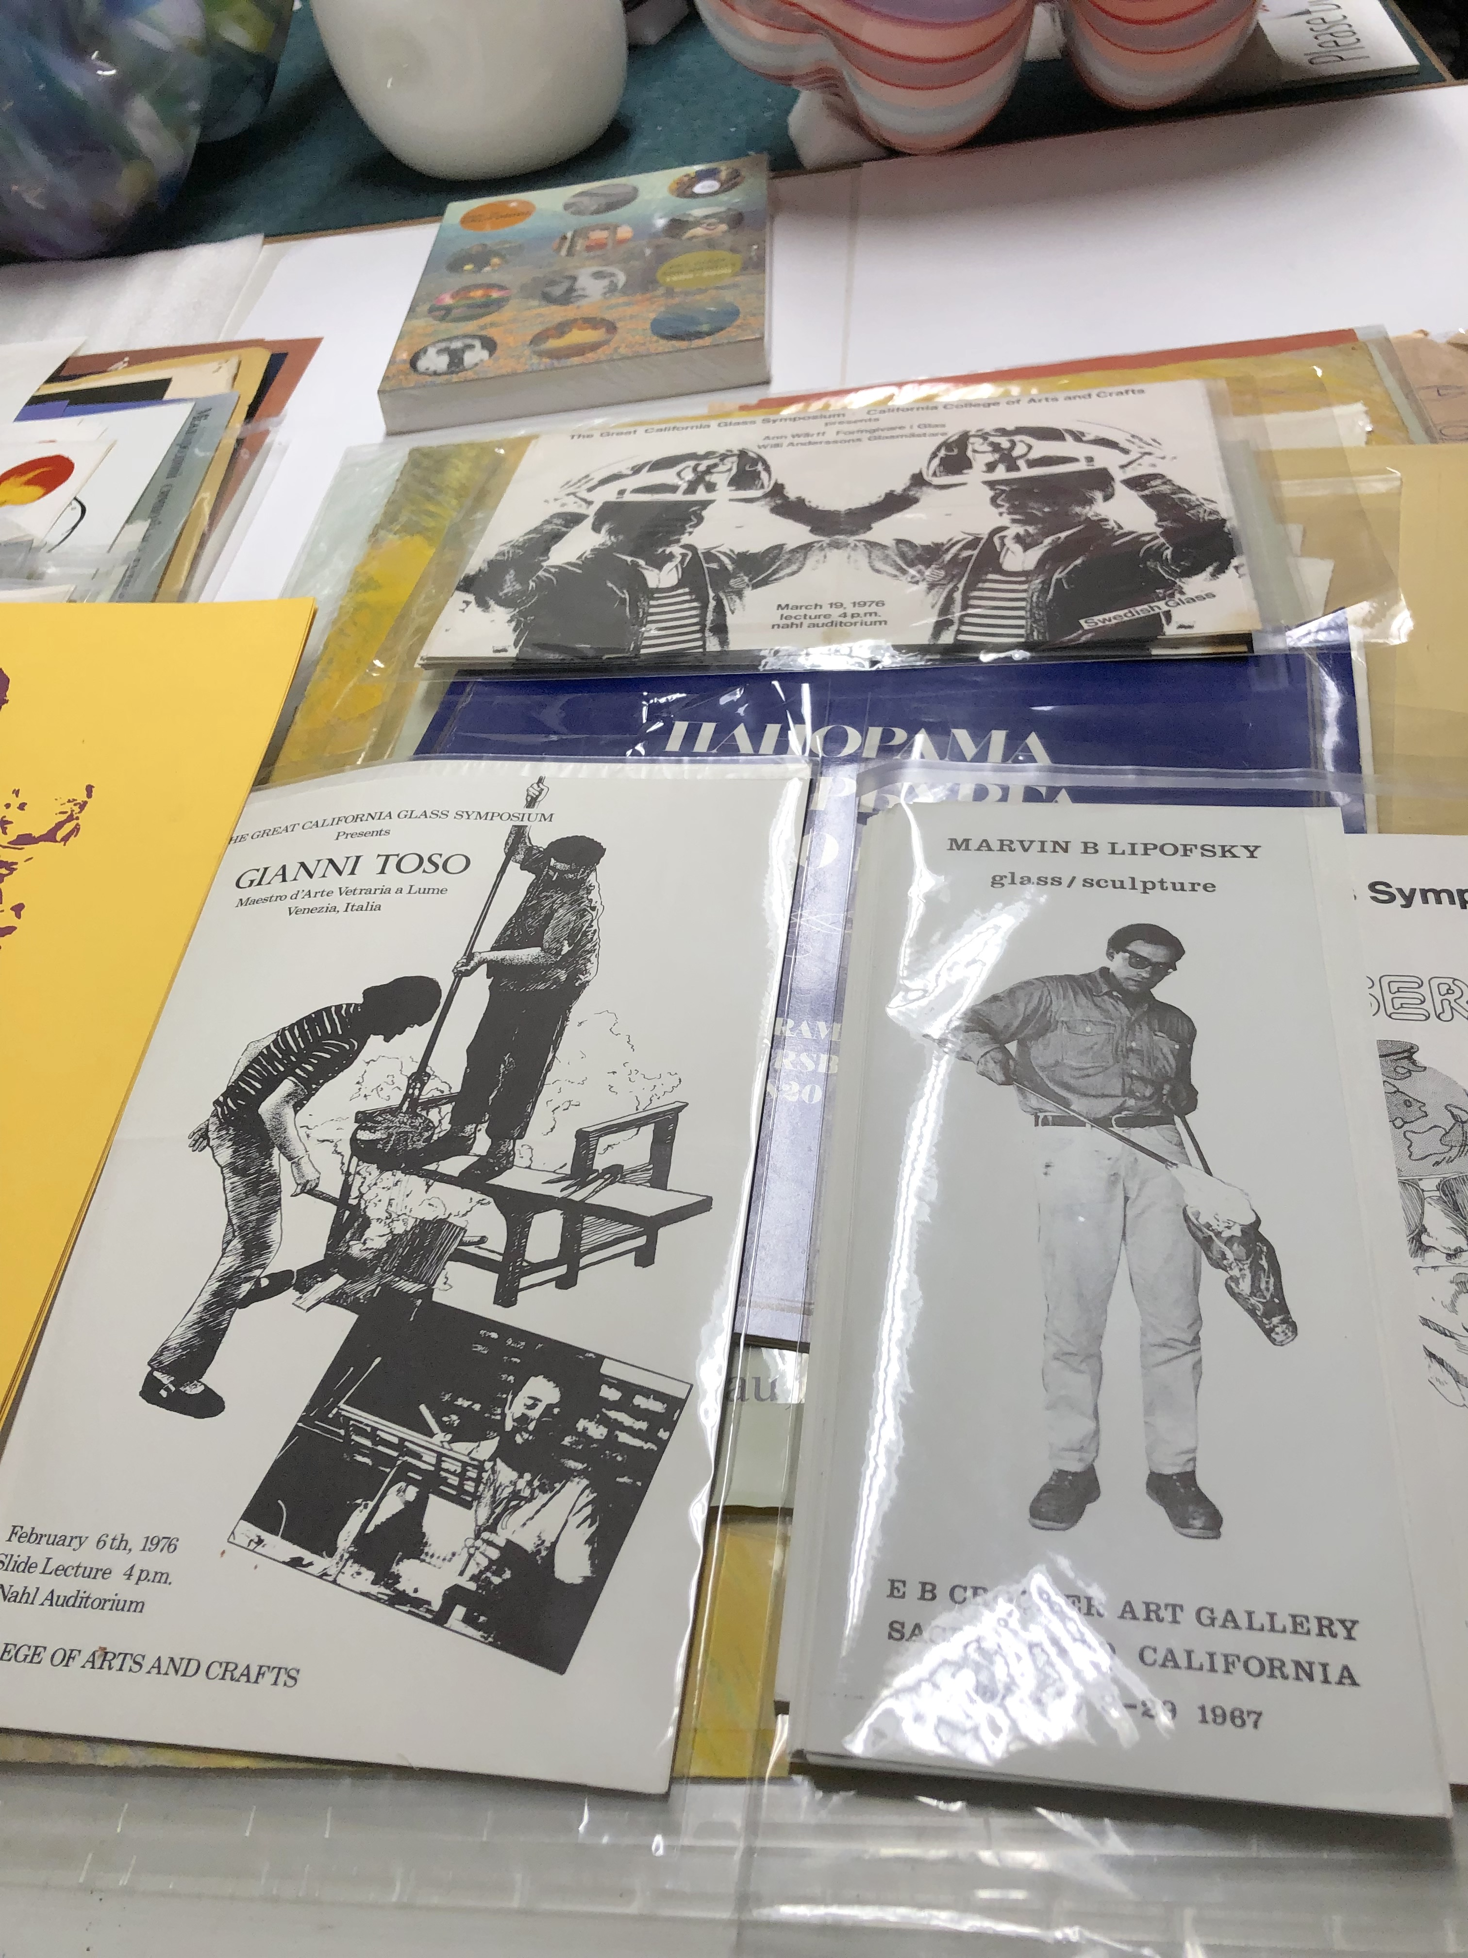
Vintage brochures

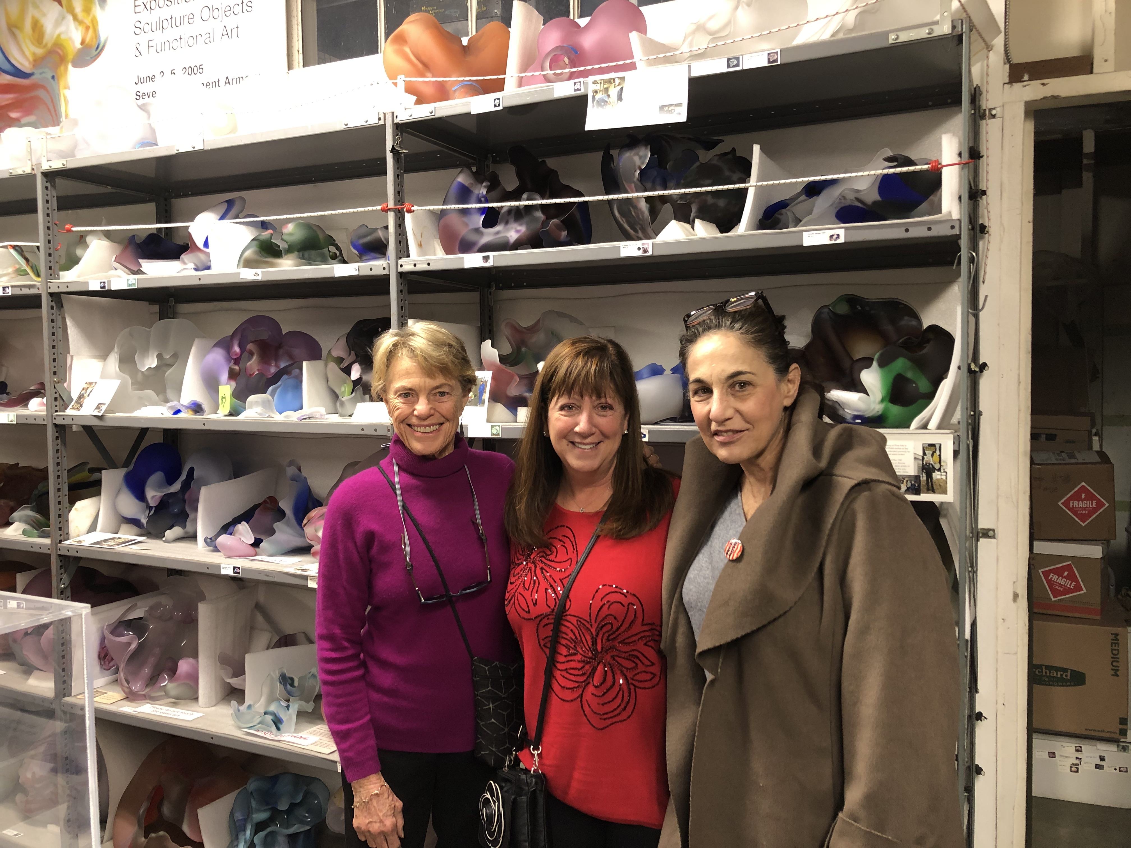
GLANC members in front of Marvin's sculptures

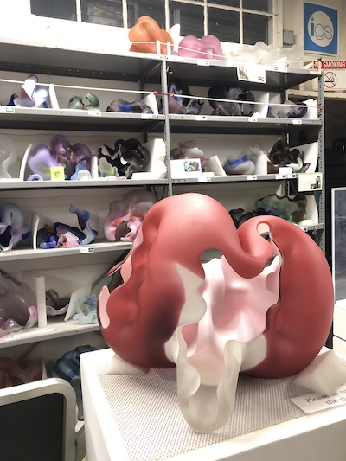
Marvin Lipofsky sculpture

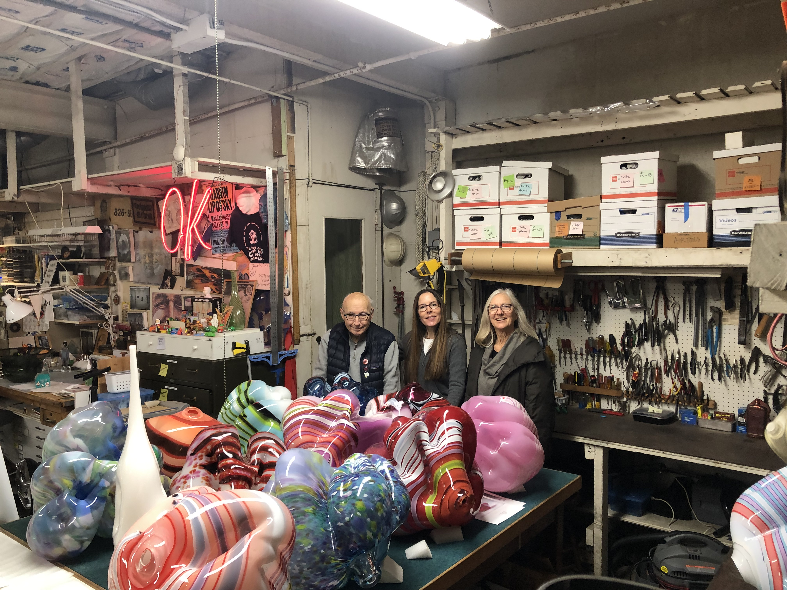
GLANC President Demetra Theofanous with Walt Riehl and Leilee Weyerhauser

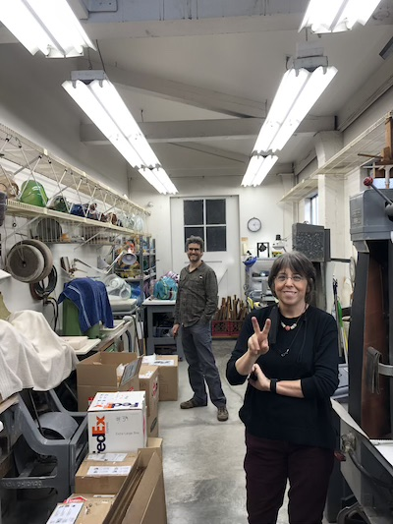
Jeanette Bokhour and GLANC Artist Member Dean Bensen in the coldshop

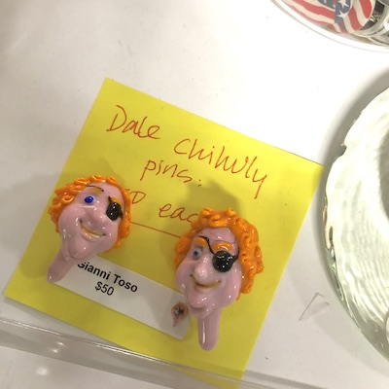

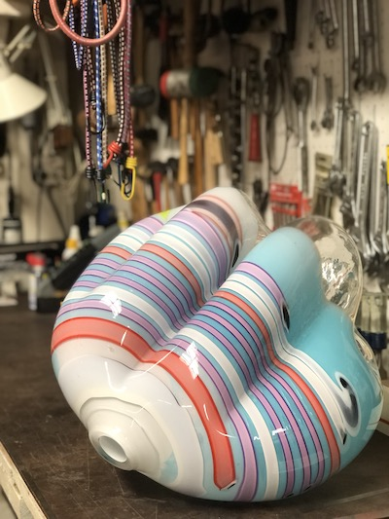

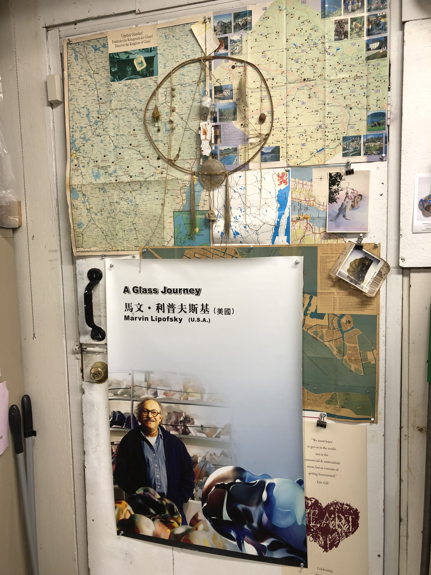
Latchezar Boyadjiev at Montague Gallery
[Demetra Theofanous]

A master in cast glass sculpture, Bay Area artist Latchezar Boyadjiev had a solo exhibition at Montague Gallery that opened last Fall in October. His exhibition "Dynamic Expressions", was greeted by a full house at the opening reception! His translucent, elegant forms, awe-inspiring scale, and tonal nuances in his work, created a beautiful display that highlighted his mastery in this medium.

His wife Bertina, an accomplished musician, was at the opening, and treated us all to an amazing musical evening as she played the harp. It was truly the perfect pairing of music and art, and I am so glad the GLANC group was able to be there to see it!

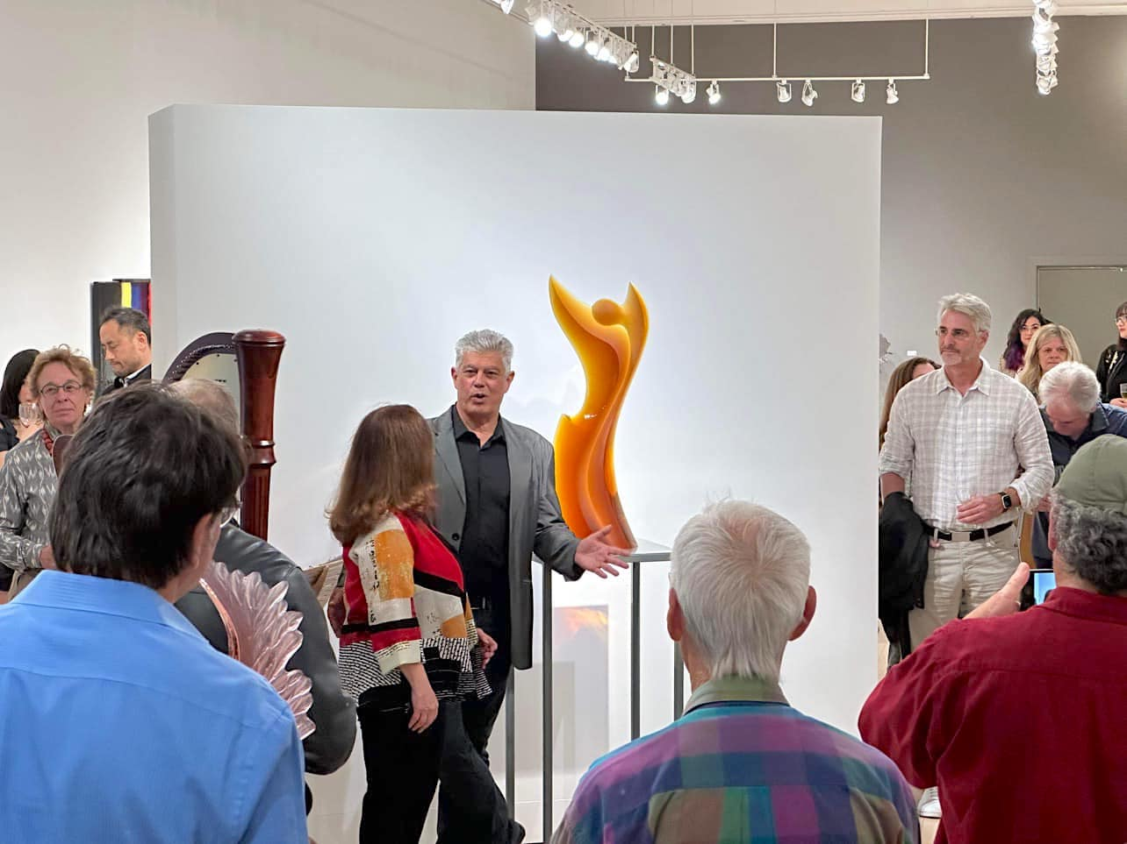
Latchezar Boyadjiev and Dani Montague next to his sculpture

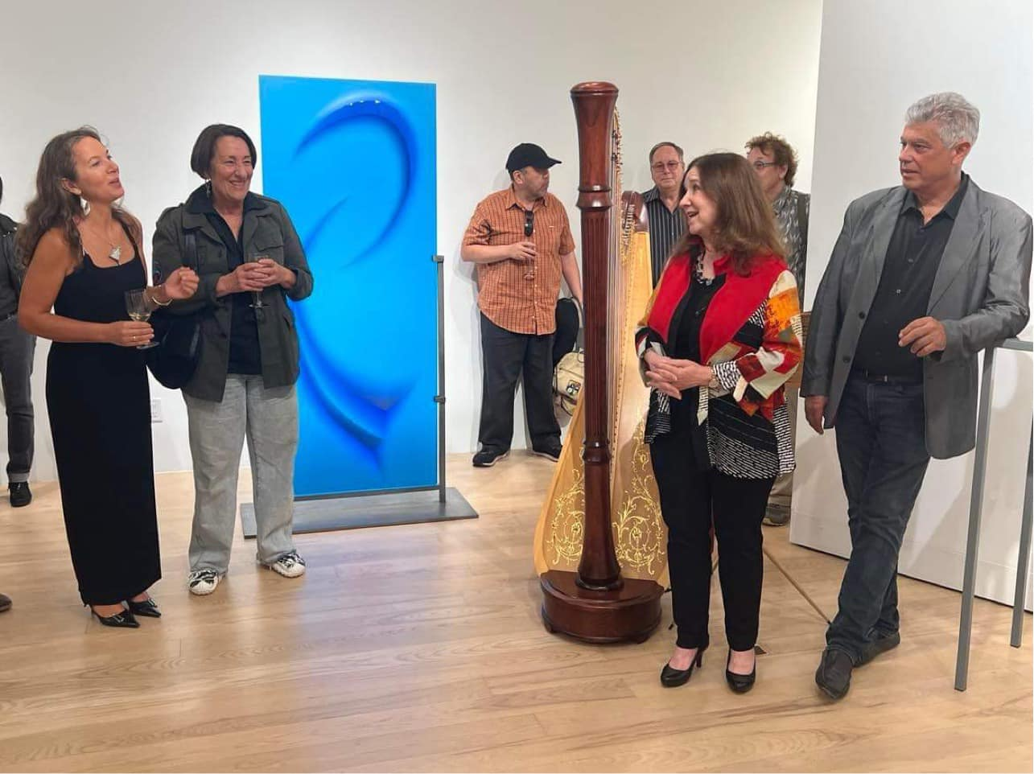Latchezar, Dani Montague, and his wife Bertina

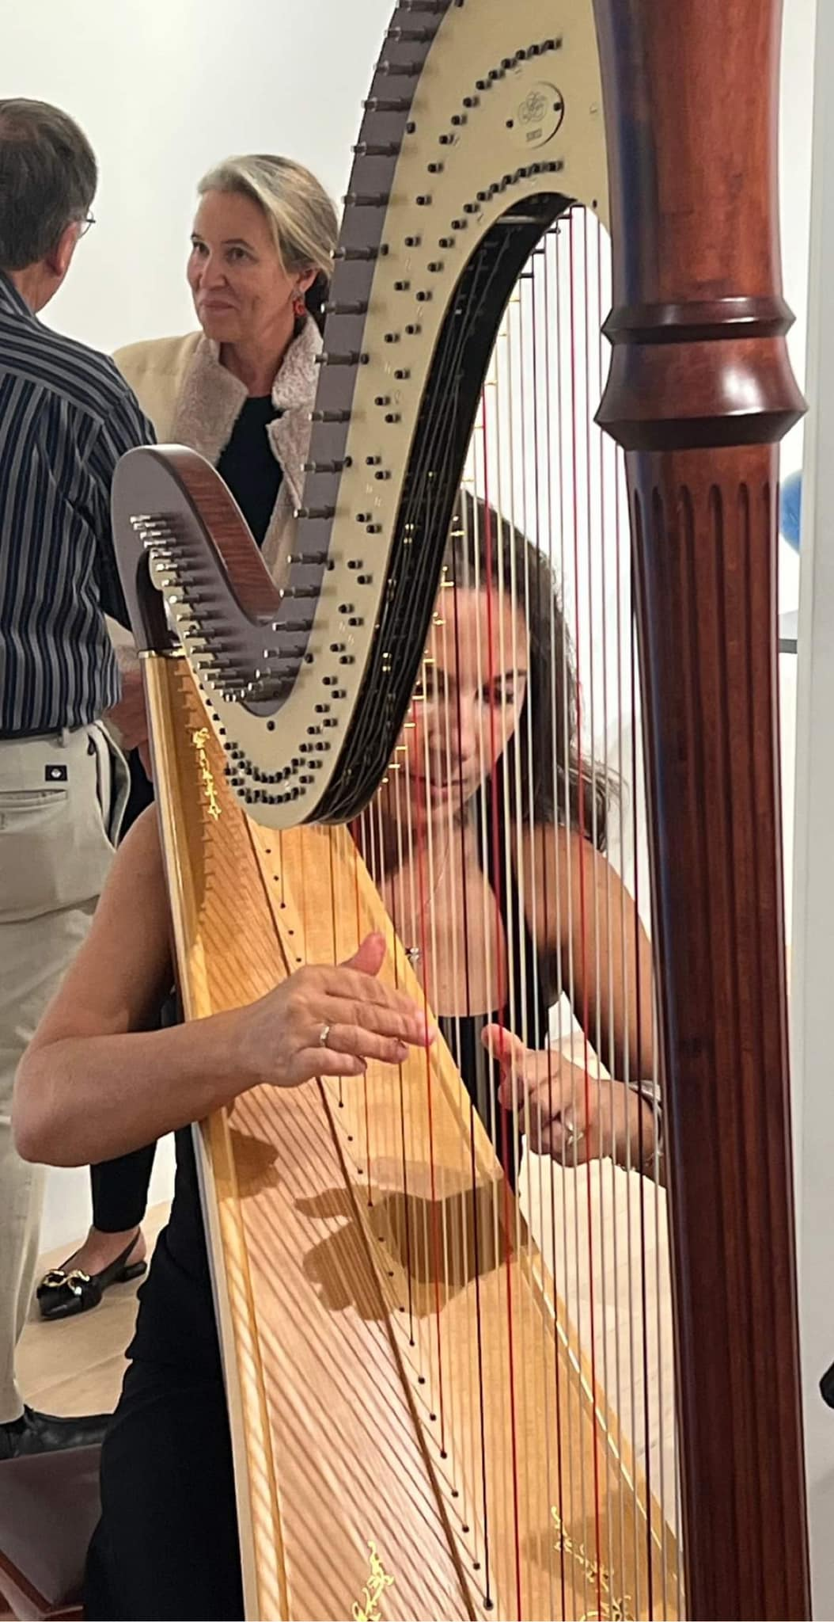
Bertina sharing her mastery on the harp at the reception for "Dynamic Expressions"

If you are in San Francisco, be sure to stop by Montague Gallery on Sutter St. near Union Square. Located near the Stockton-Sutter parking garage, you can still view Latchezar's sculpture in the gallery, if you missed the show!

THE DE YOUNG OPEN

Building on the tremendous success of the inaugural de Young Open in 2020, the second triennial of this juried community art exhibition celebrates the voices and visions of Bay Area artists. The 883 works that were on view were created by artists living in the nine counties surrounding San Francisco Bay,. This year, 7,766 talented artists each submitted one artwork hoping to be accepted to the show. 883 works made the final cut with only 35 of those being sculptural works. The submissions were juried by eight curators of the Fine Art Museums of San Francisco, as well as 3 distinguished Bay Area artists.

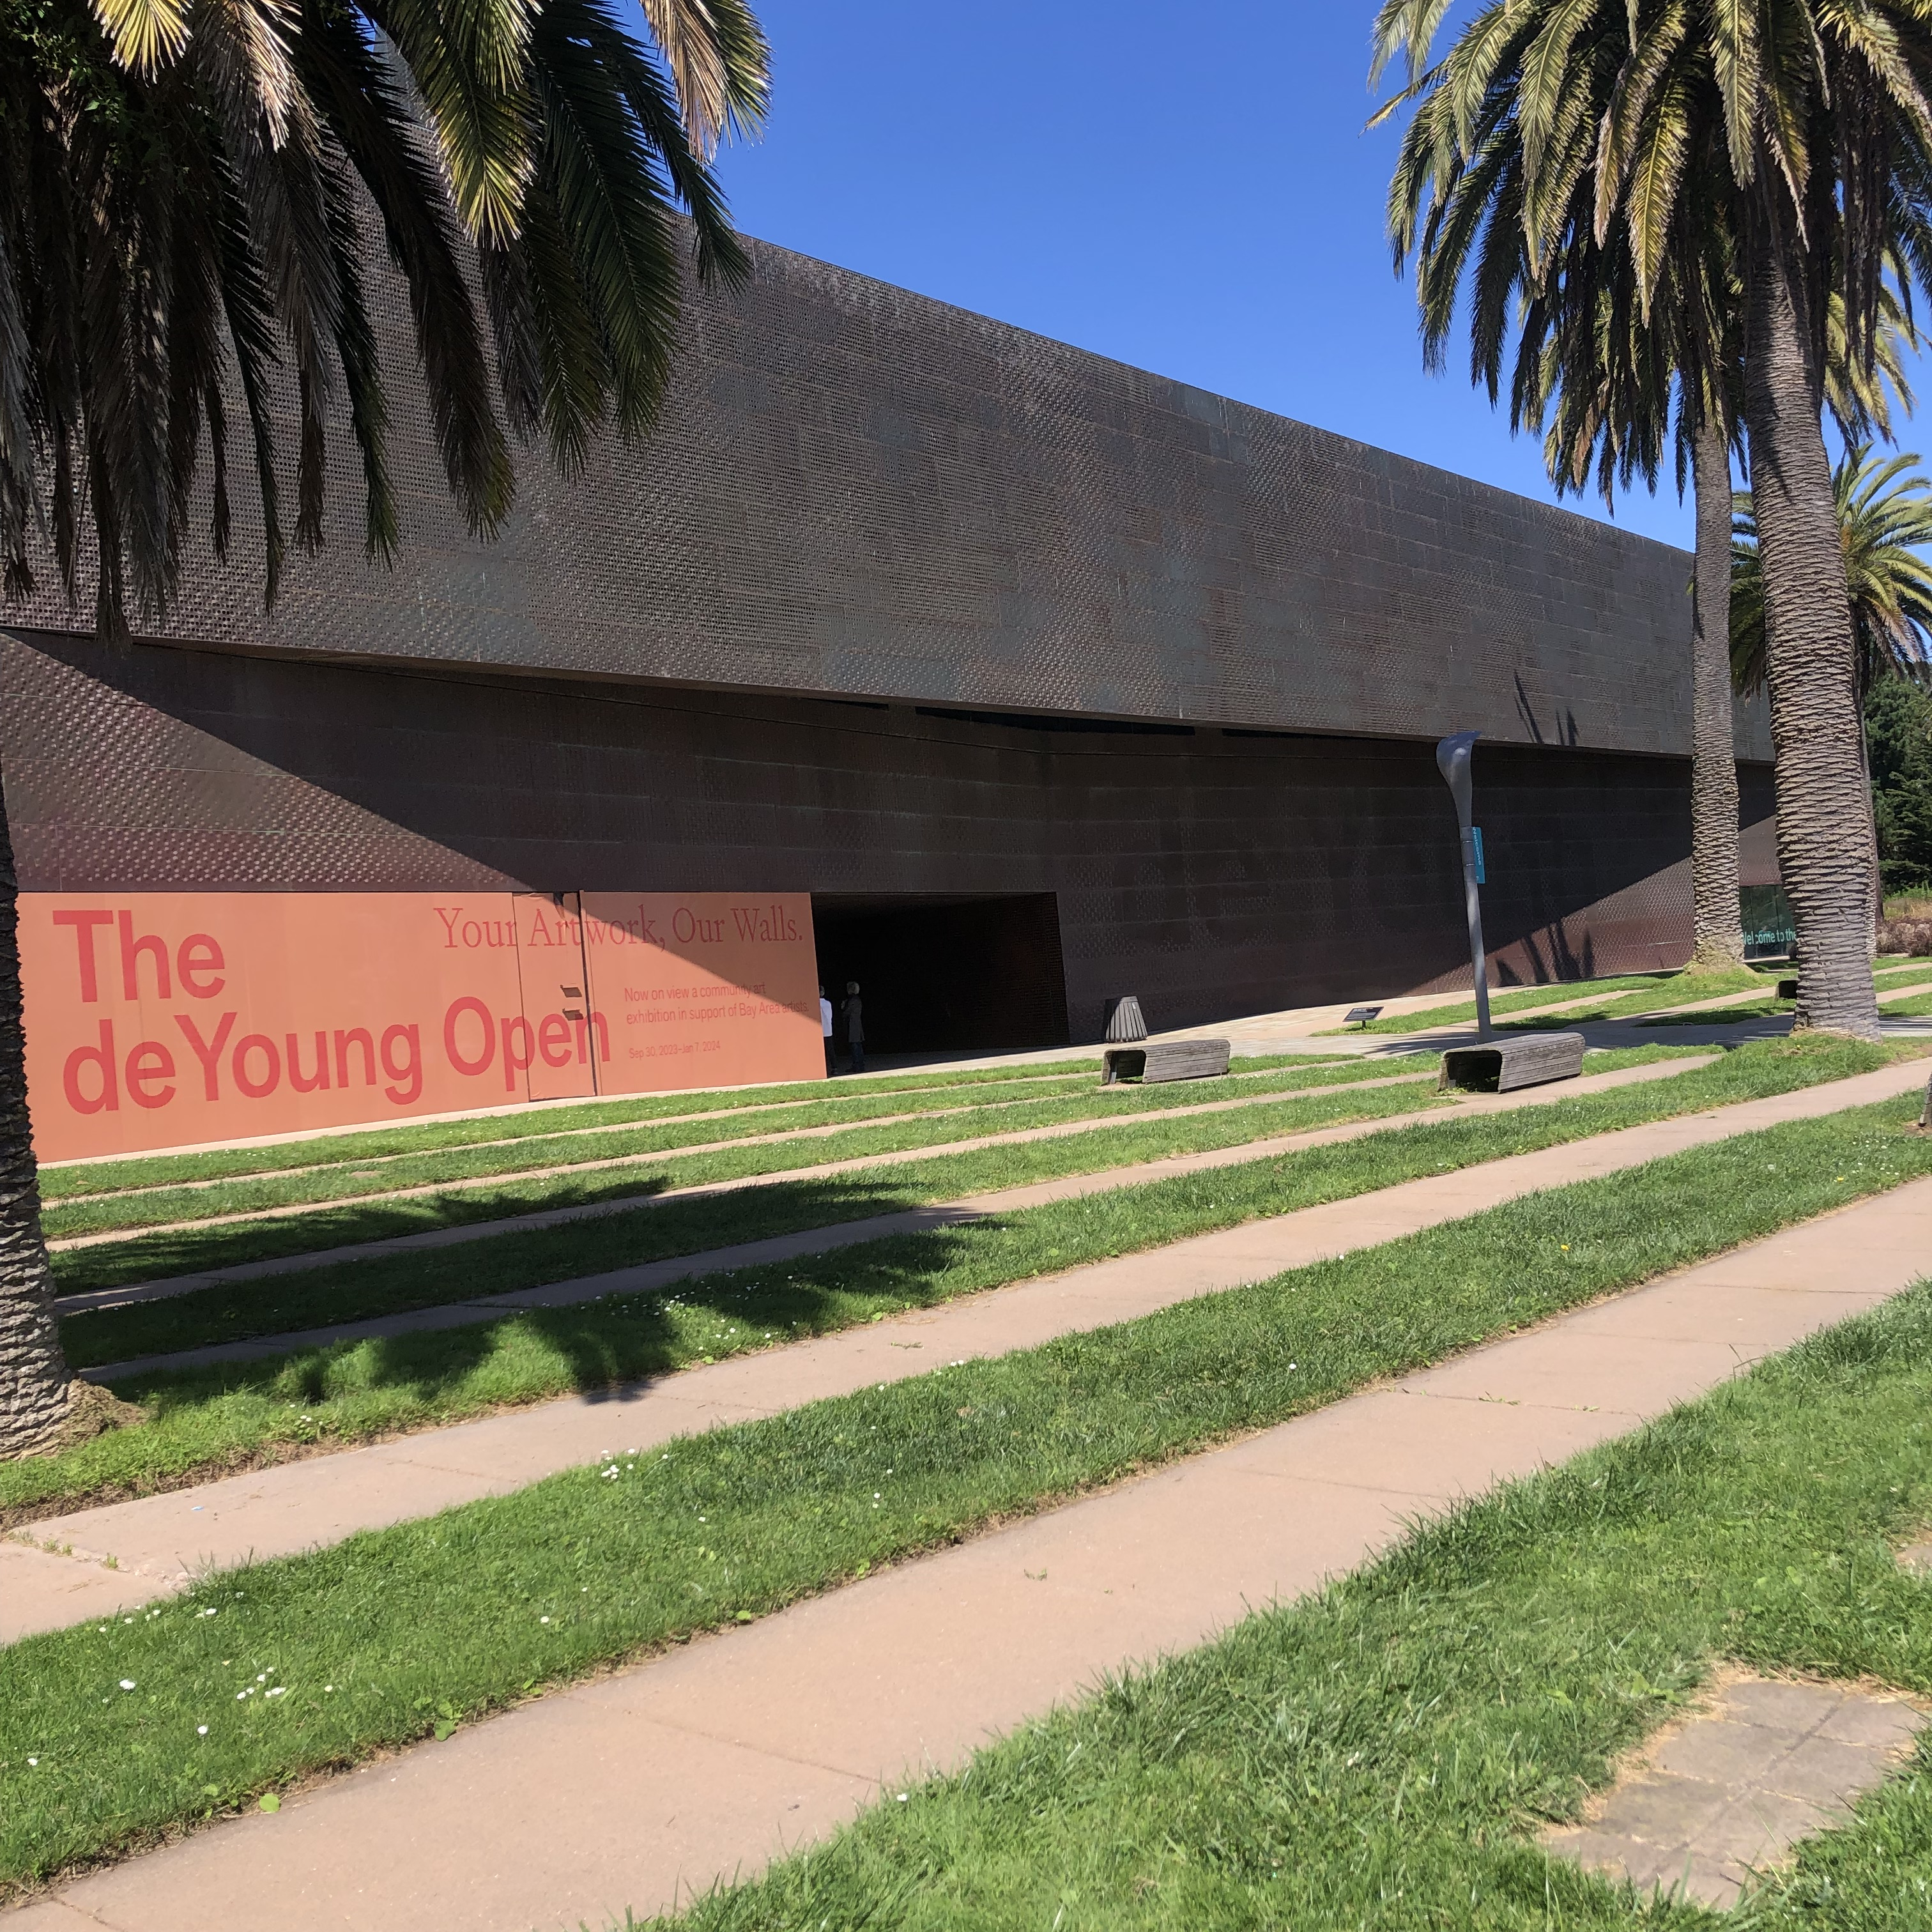
The de Young Museum, San Francisco

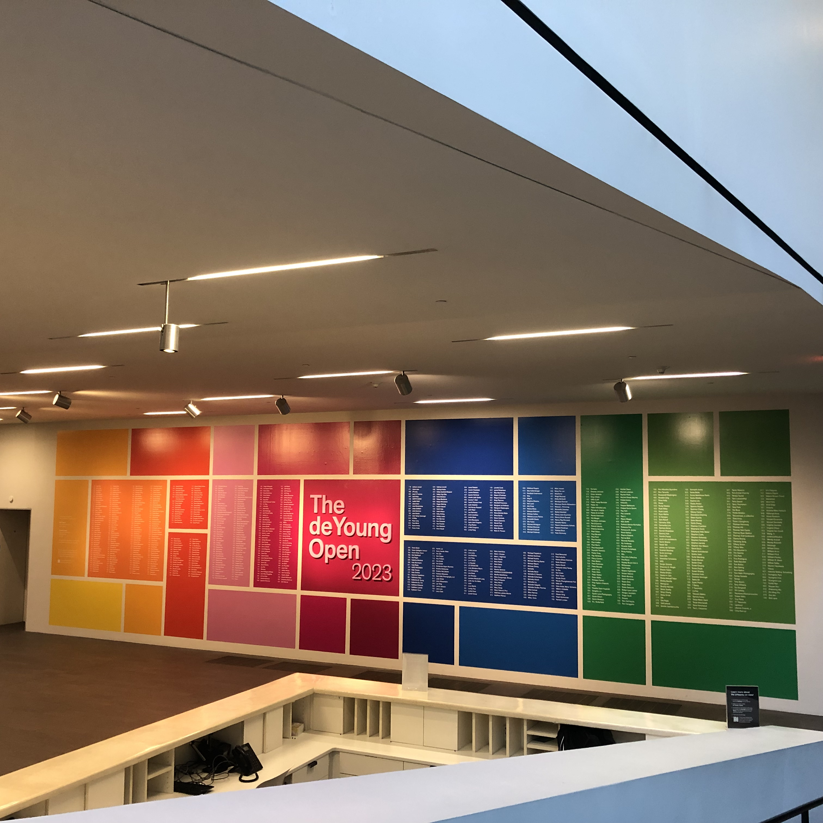
Each of the 883 artists accepted to the show, had their name on the wall in the de Young Museum during the exhibition.

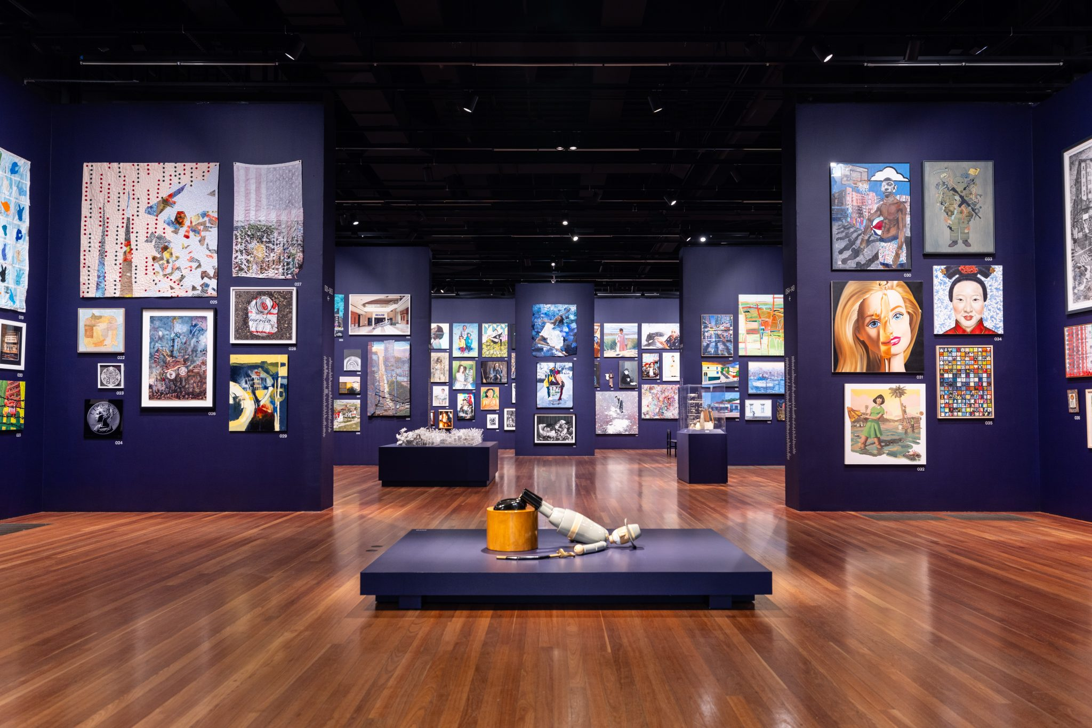
Opening room of the de Young Open exhibition
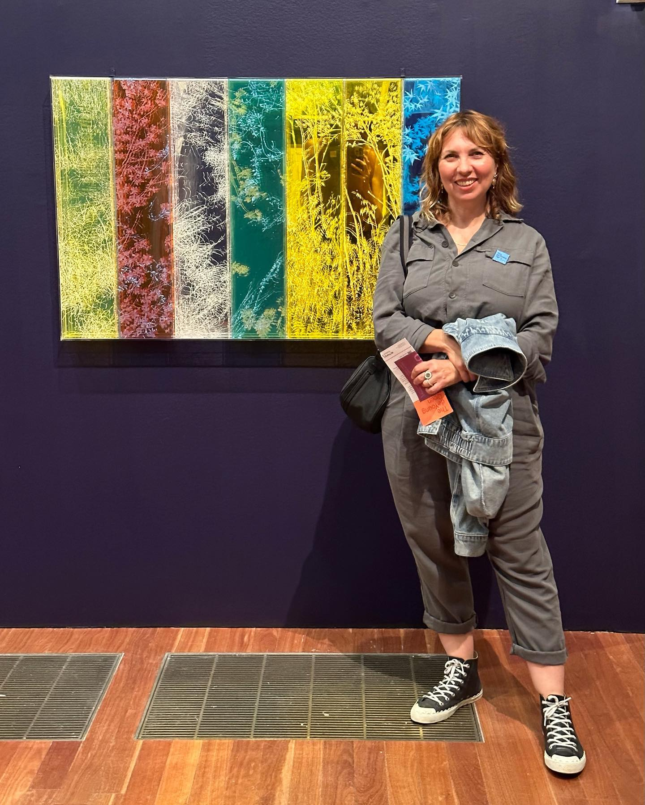
Natalya Burd by her work - meet her at our GLANC Day Tour event on March 2nd!

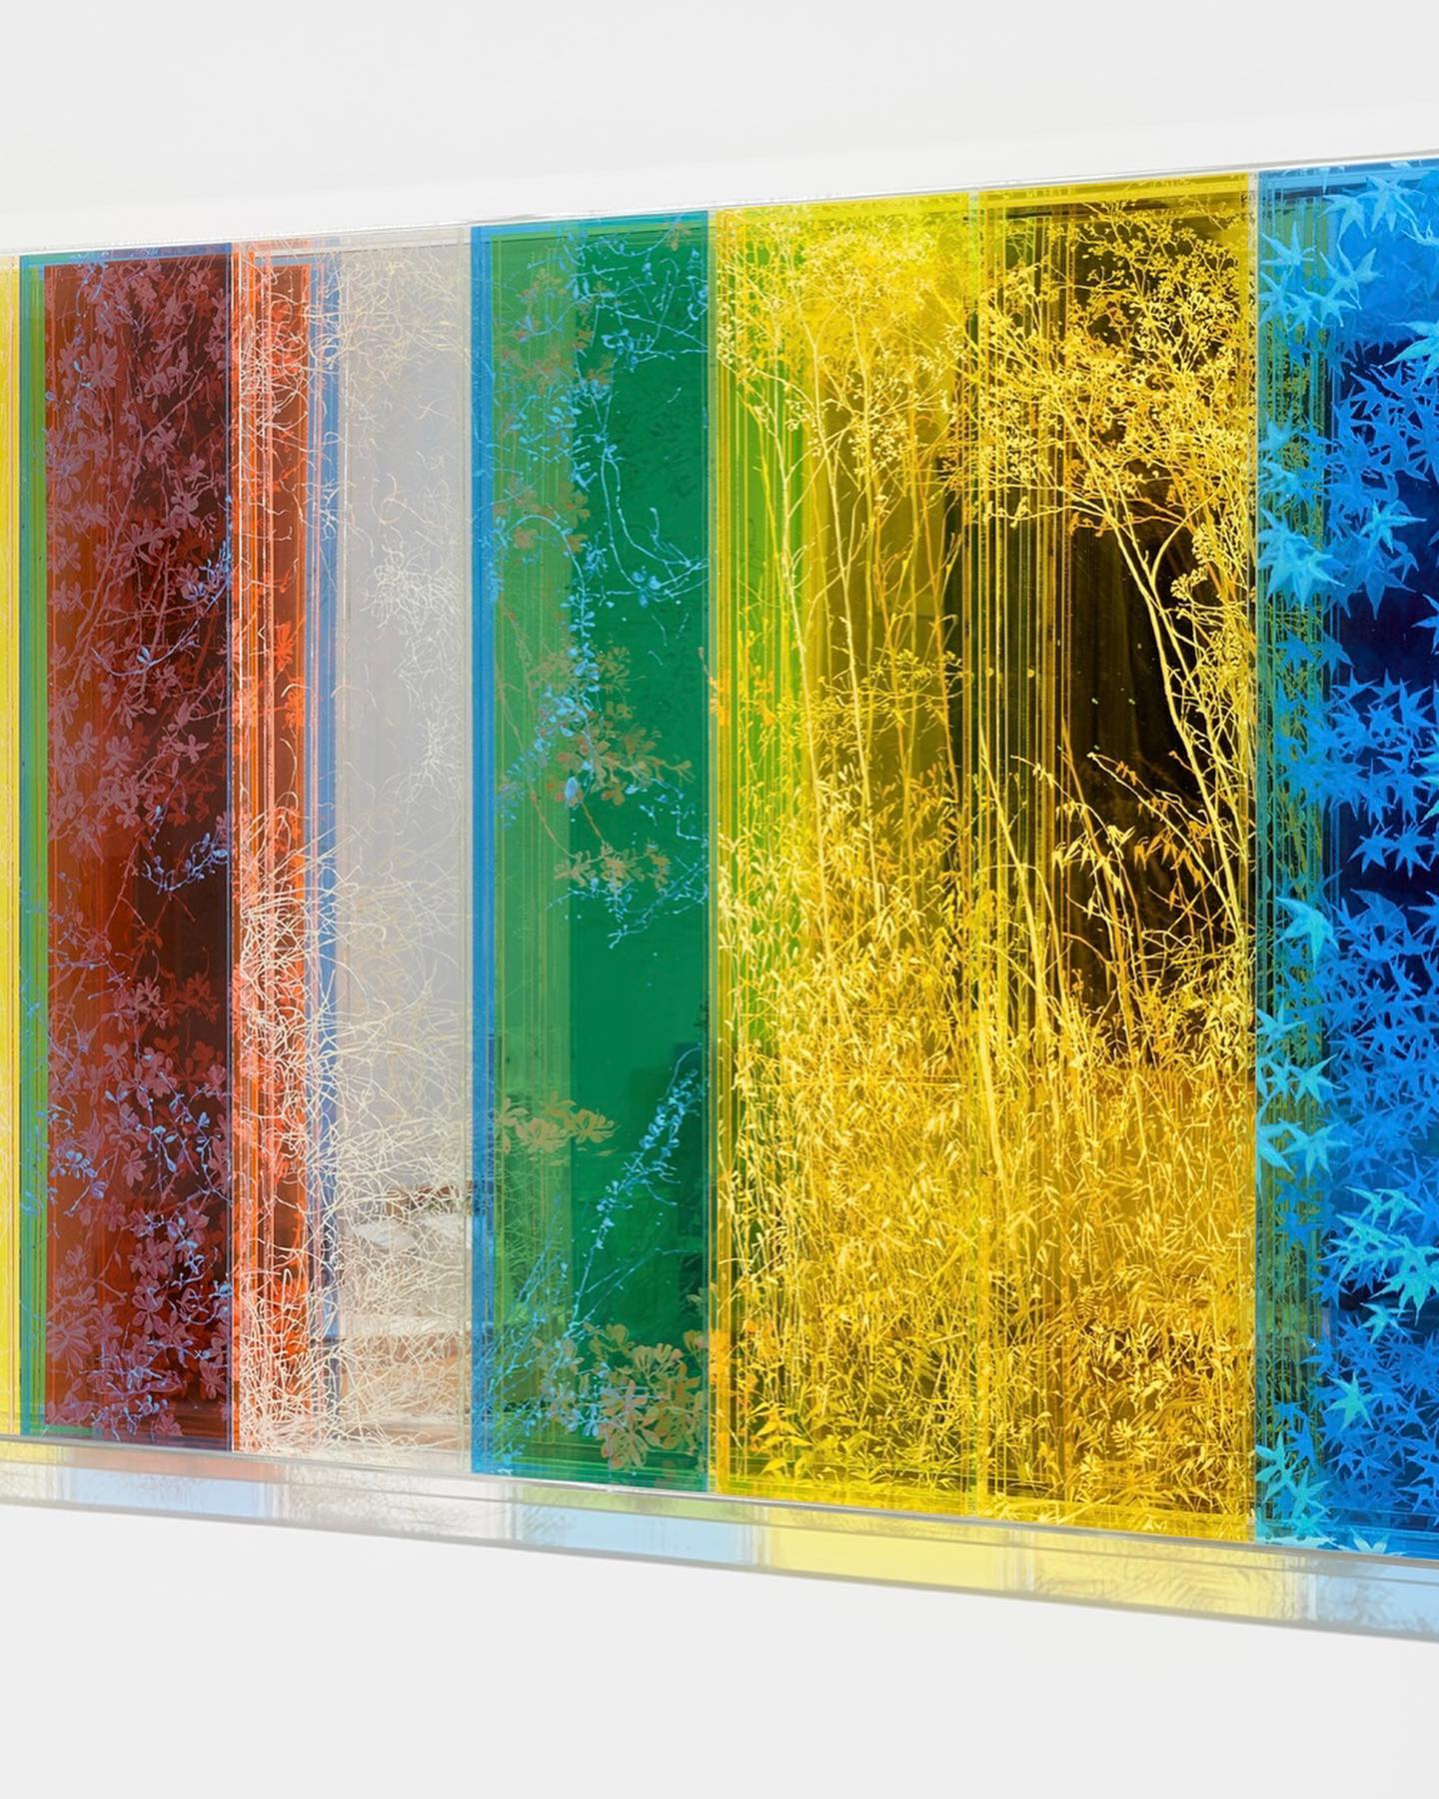
Another view of Natalya Burd's glass art in the de Young Open

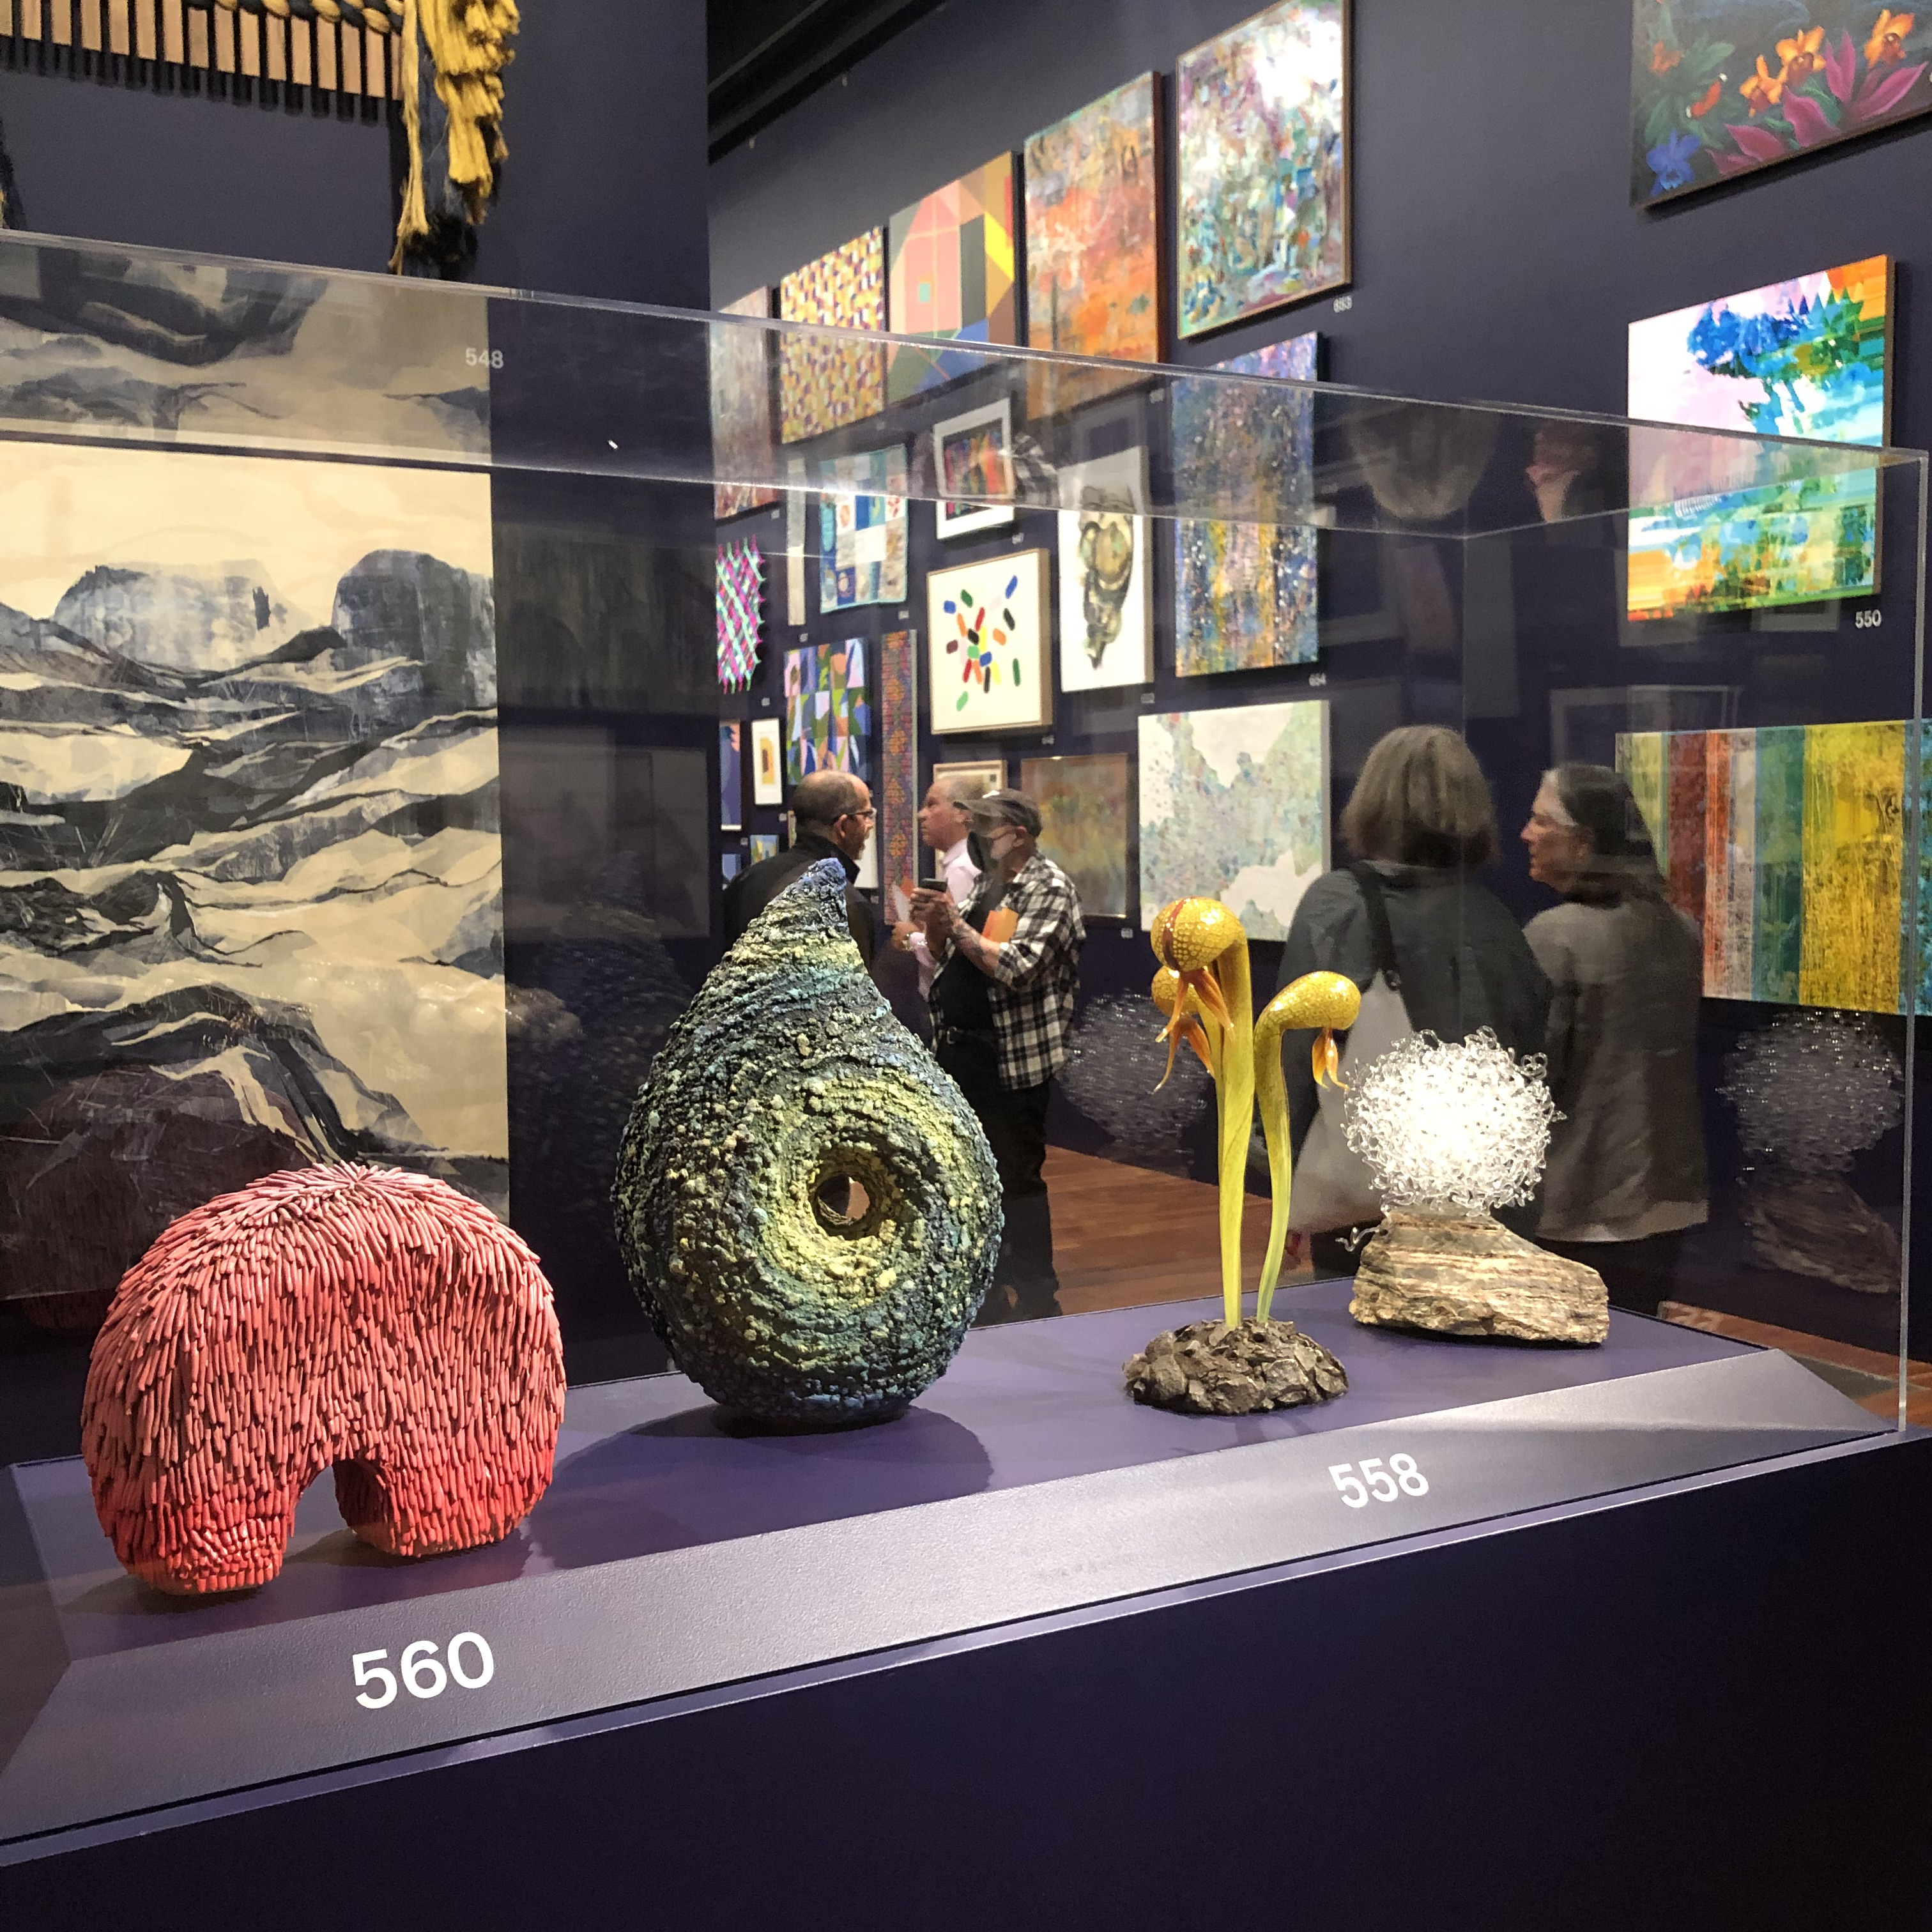
Artwork 558, glass sculpture by Evan Kolker

Artworks were hung "salon style" and grouped by theme: political and social issues, the urban environment, the human figure, nature, abstraction, and surreal imagery. There were a few pieces of art using glass as a medium, represented in the show, including sculptural work by GLANC President and artist member Demetra Theofanous. GLANC artist member Tomye-Neal Madison, pictured below, also had a work in the show featuring one of her 2 works.
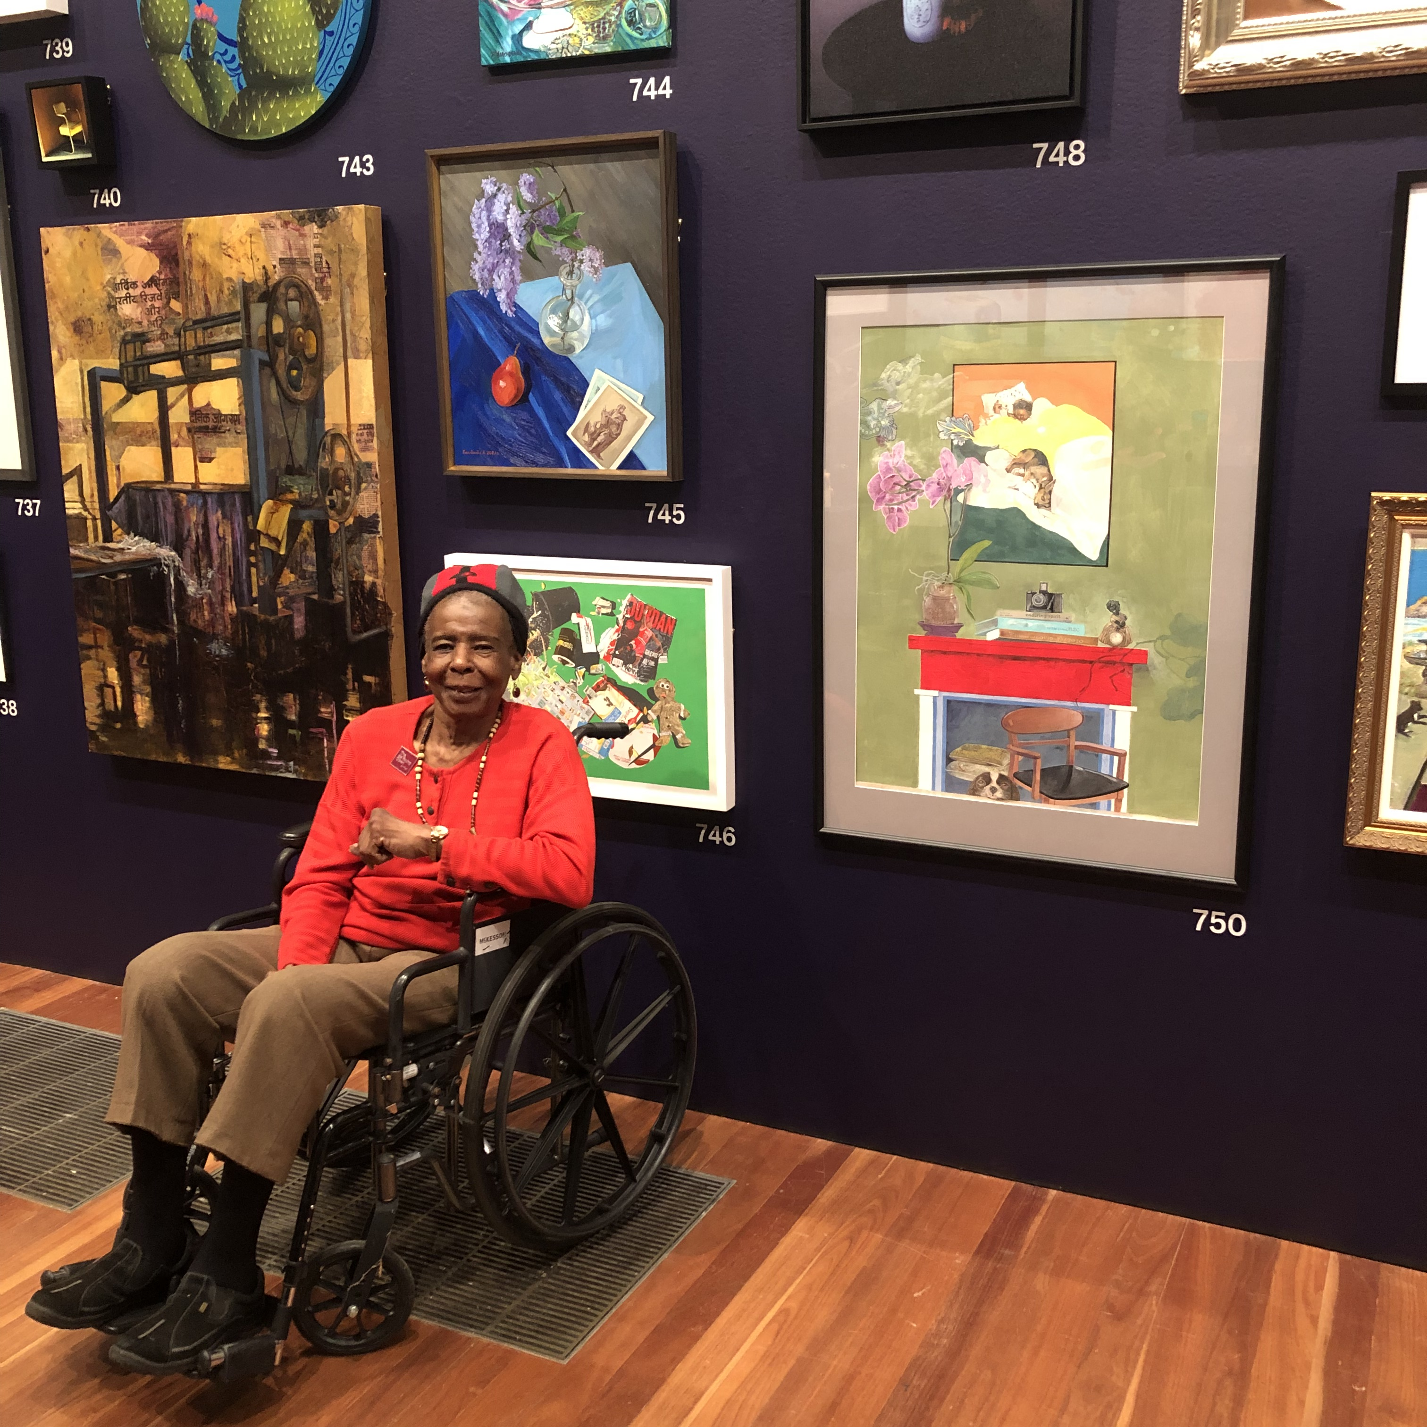
GLANC artist member Tomye-Neal Madison by her artwork #750

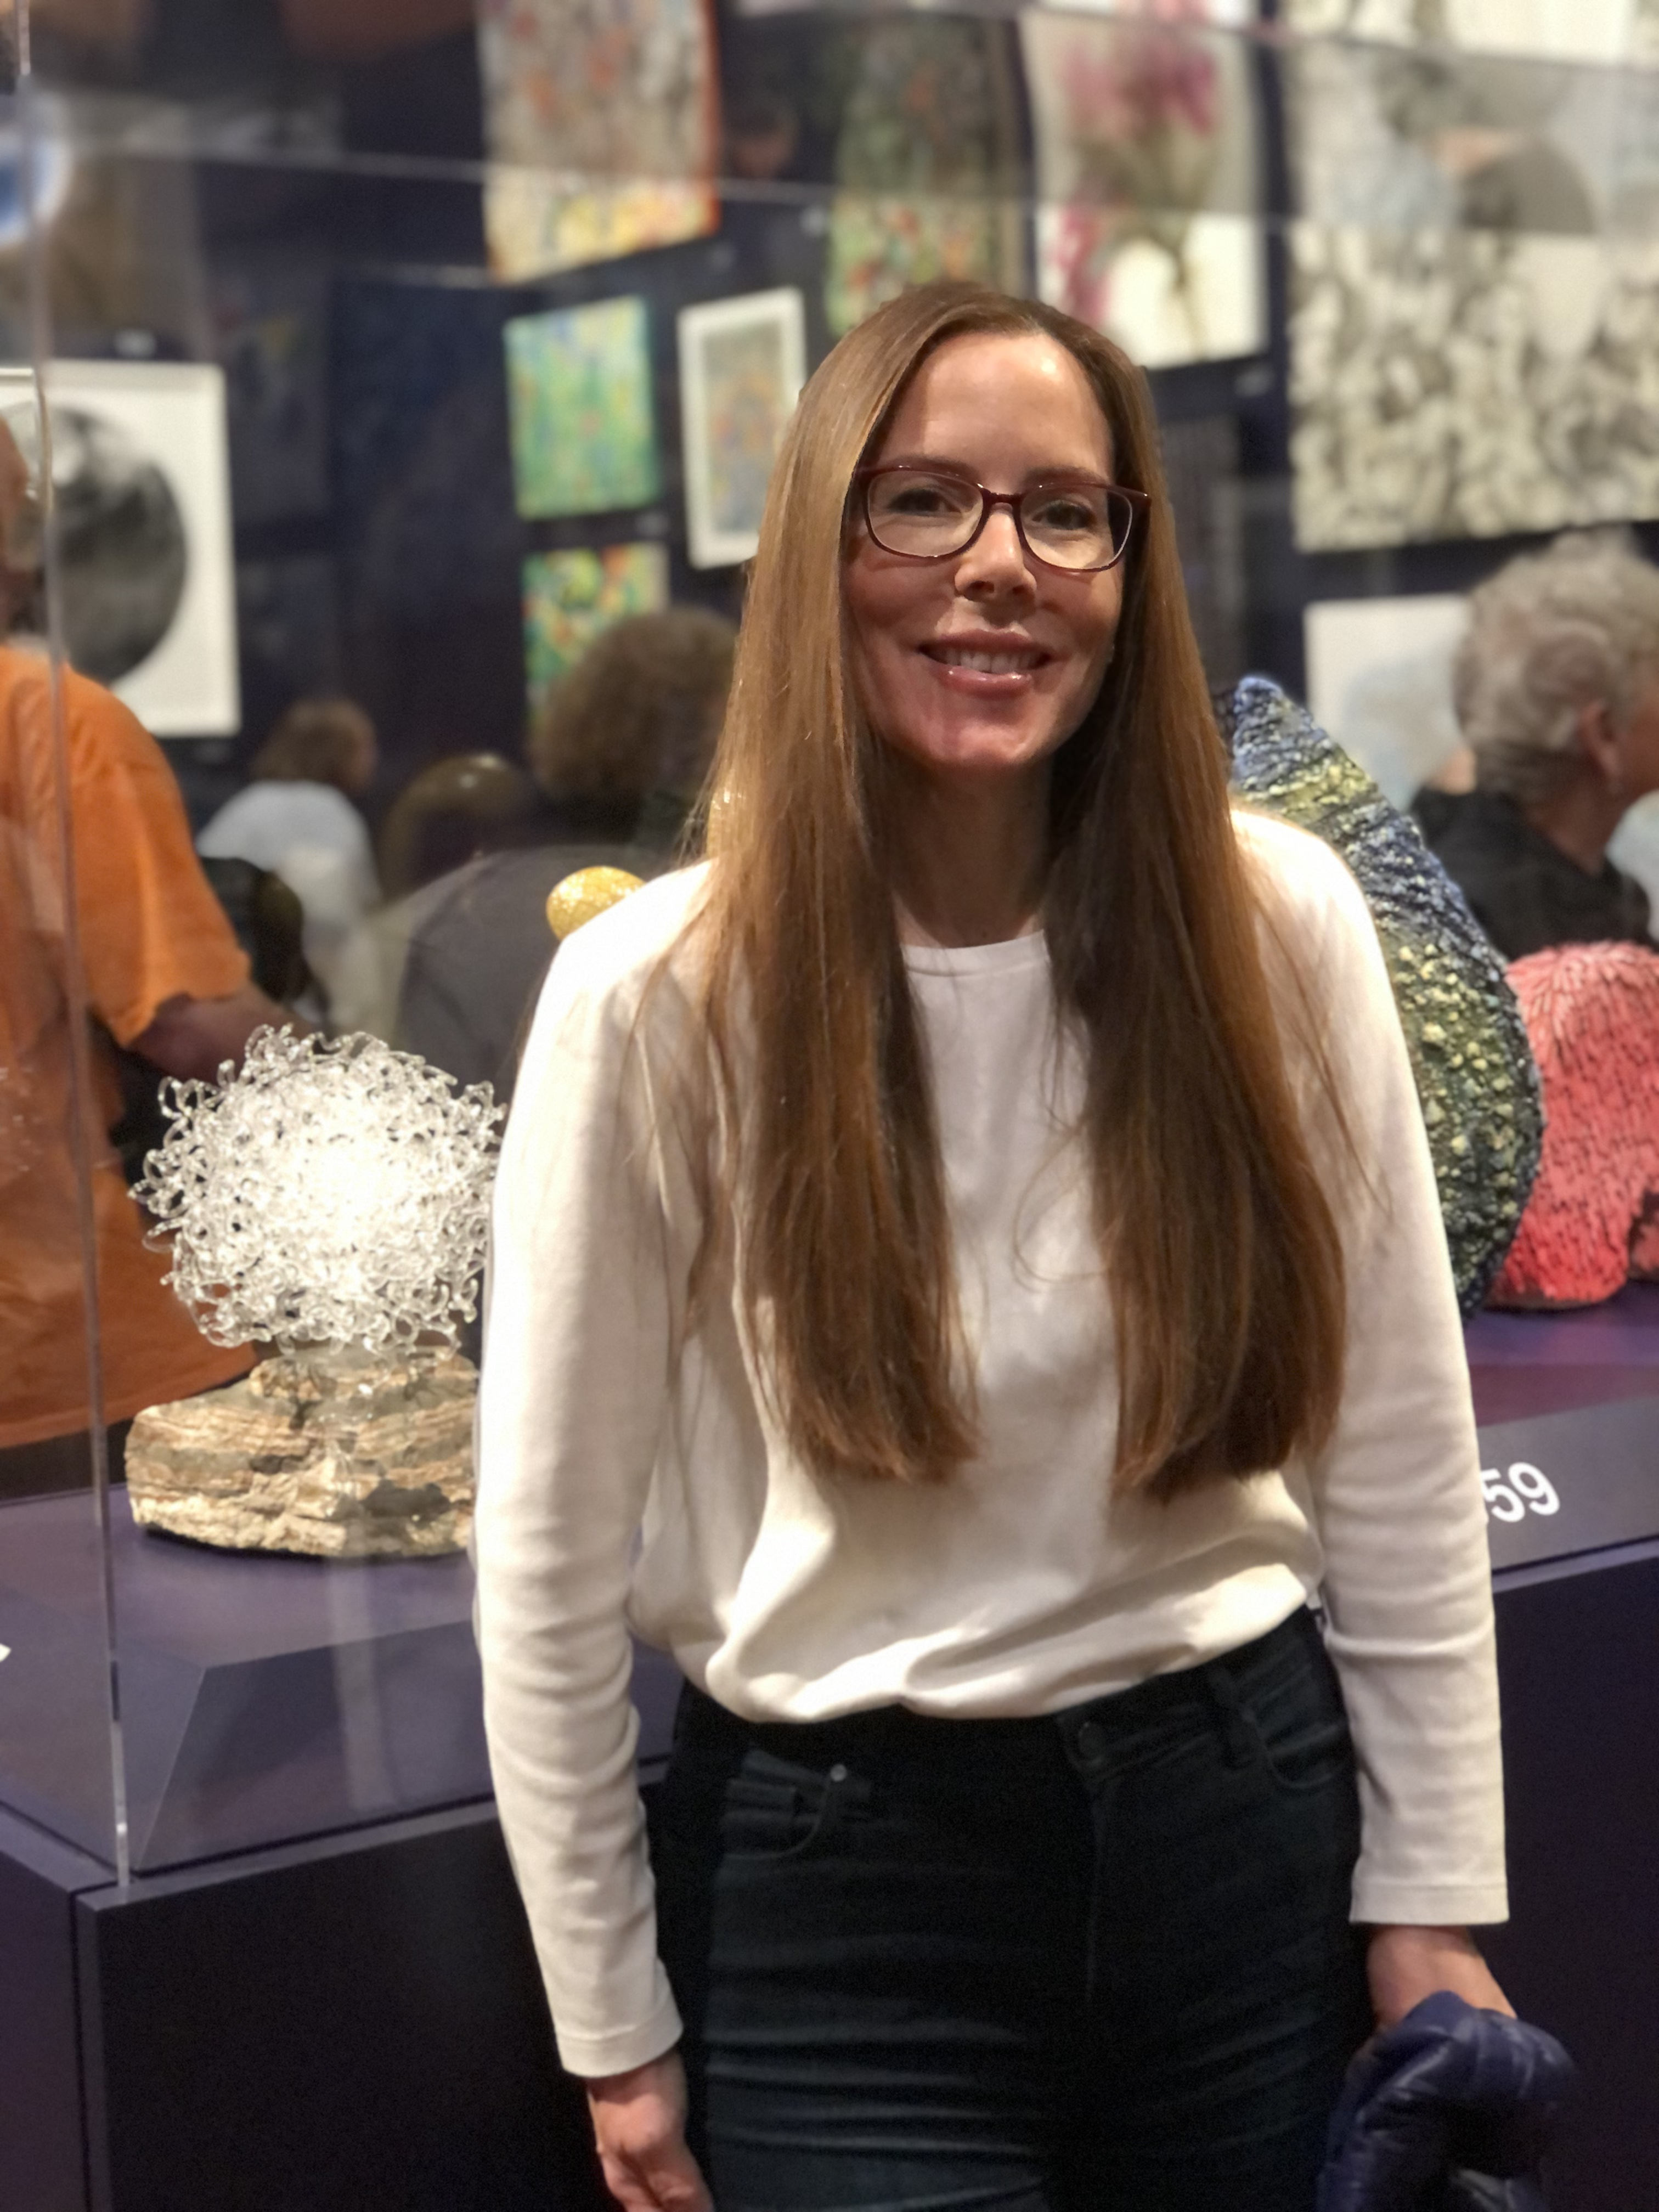
GLANC President and artist Demetra Theofanous in front of her work, "Tangled Landscape"

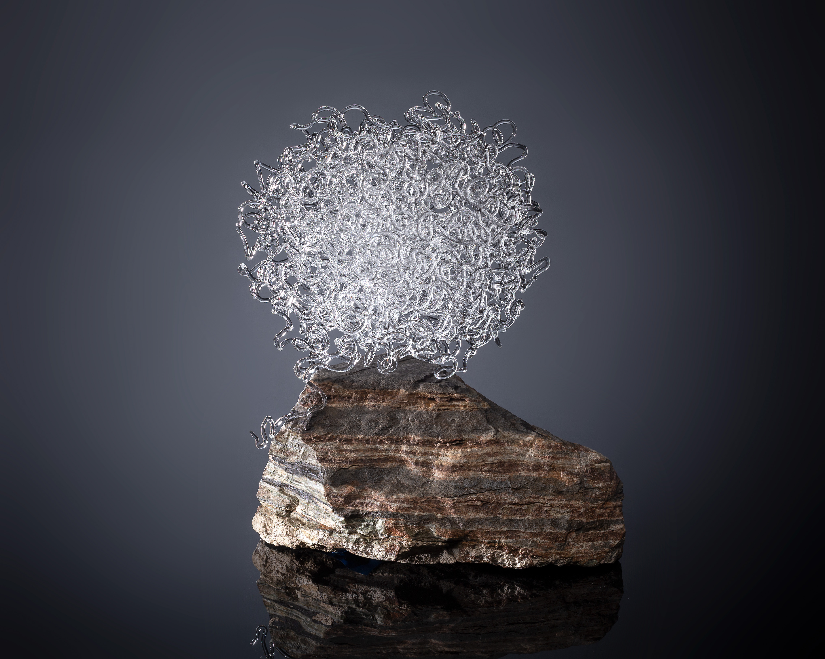
"Tangled Landscape" by Demetra Theofanous

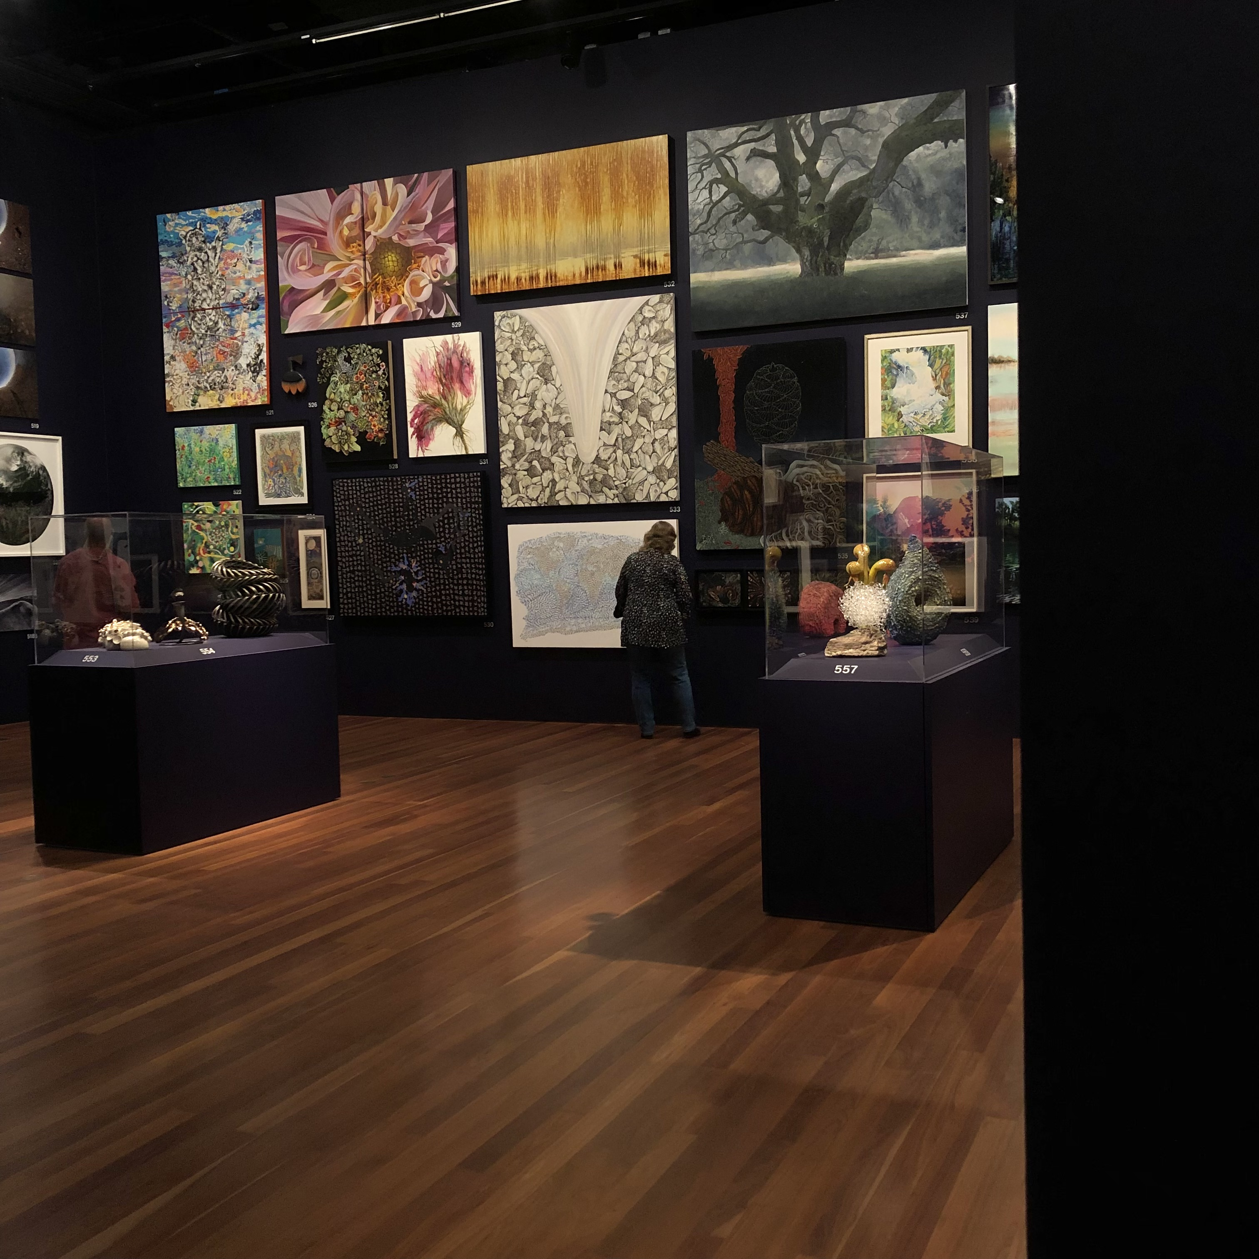
One of several rooms in the exhibition

The de Young Open was a unique model to get the community re-engaged with art, and to feature exceptional regional talent. With amazing reviews in the New York Times, and Hyperallergic, as well as many other publications, things look promising that this triennial will continue in the years to come!

CHRISTINA AMRI'S FAREWELL
[Demetra Theofanous]

After decades creating glass art, Christina Amri has made the decision to step away from her business. She built her business in architectural glass, and has been the founder, principal, and lead designer of Amri Studio in Oregon.

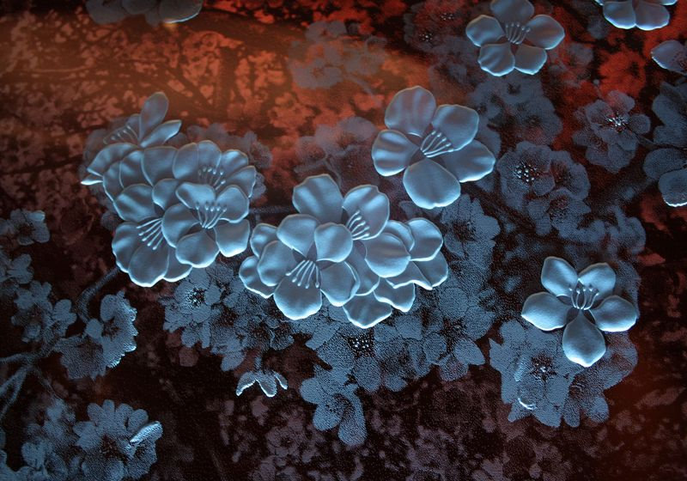

Amri began her training in Paris in the early 1970s, where she apprenticed with a highly respected 4th generation stained glass studio. There she had the unparalleled opportunity to work on the restoration of the famed windows of Chartres cathedral.

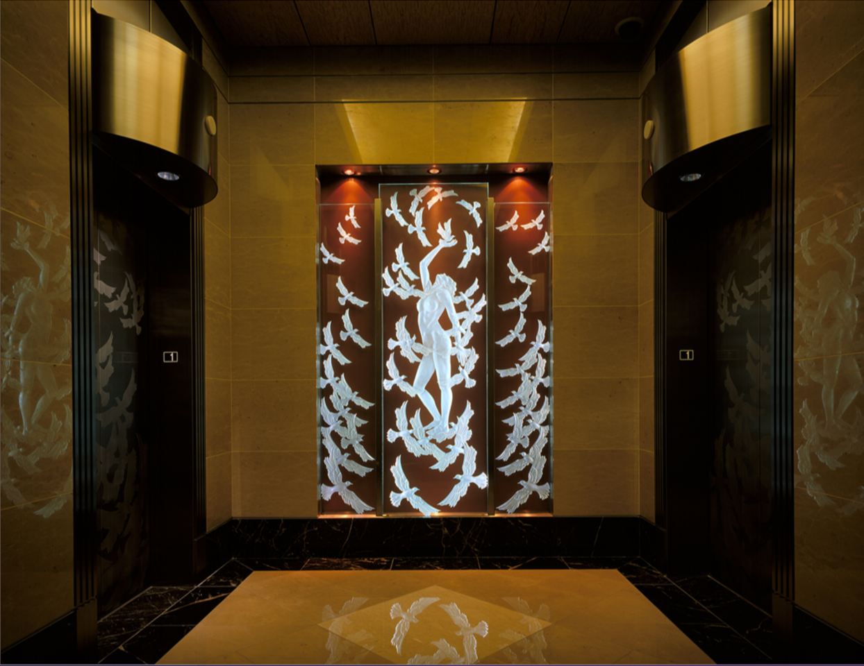

When sunlight streamed through those windows, they were said to "transform everyday light into the light of paradise". This was the beginning of Amri's personal commitment to creating timeless permanent monument style works of art with striking beauty and deep messaging in the work. Over the course of her career, she took a special interest in designing work that honored children, women, and families, and work for sacred architectural spaces such as Chapels and reflection rooms for spiritually based organizations.

After an incredible and long career, Christina Amri is selling off her remaining pieces, and saying farewell to glass. If you are interested in reaching out to Christina, please do so directly.

SMITHSONIAN VISIONARY AWARDS
[Demetra Theofanous]

The Smithsonian Visionary Award was presented this year to two amazing glass artists, Dan Dailey and Judith Schaechter.

Dan Dailey was honored for his innovative and dynamic sculptures that combine glass, painting, and often humorous narratives.

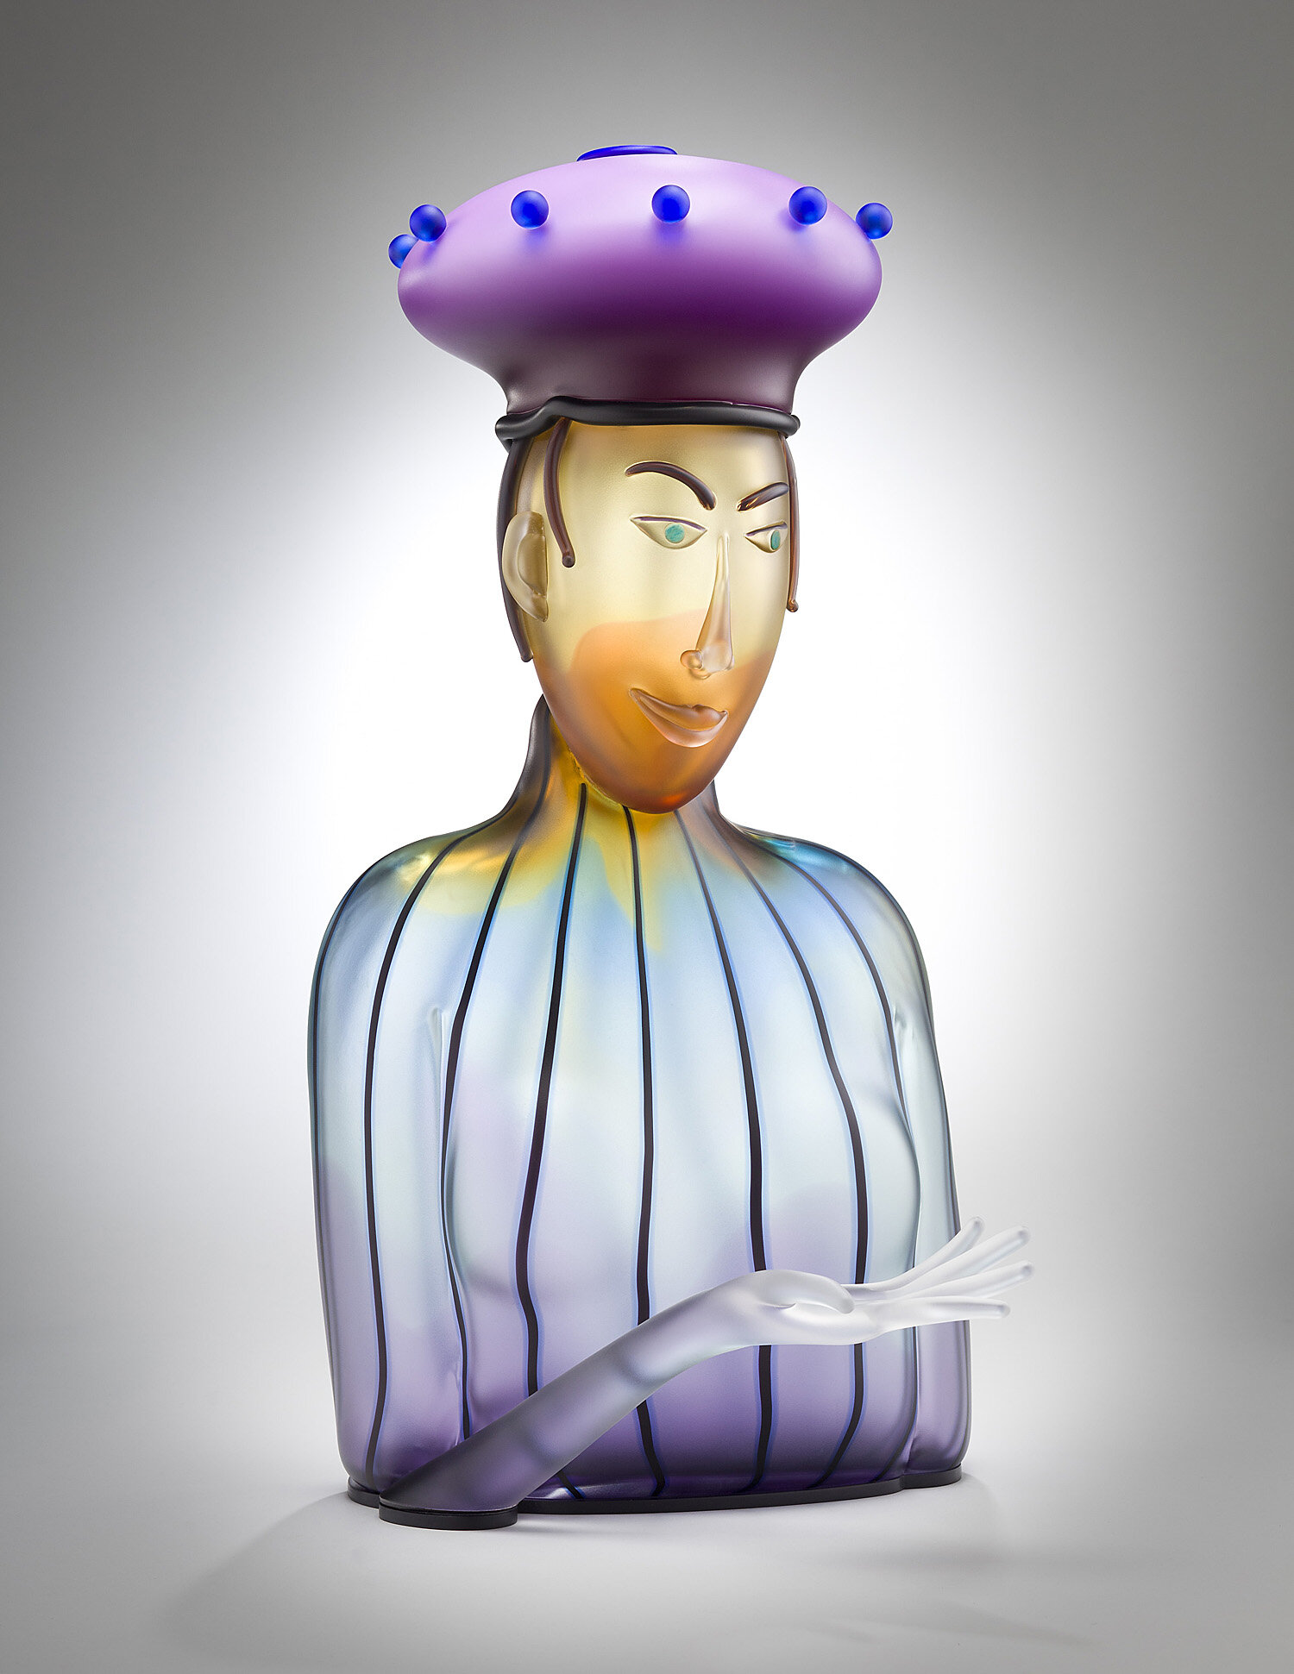
Dan Dailey, "Wonder"

Judith Schaechter was honored because of her incredible artistry that combines ancient tradition in stained glass with contemporary techniques. Her work is meticulous and painstaking, as she works through layer after layer of glass, to create captivating imagery and tell a story.

The Smithsonian Visionary Award is presented annually by the Smithsonian to American artists deemed by experts in the field to have achieved the pinnacle of sculptural arts and design, in their respective medium.

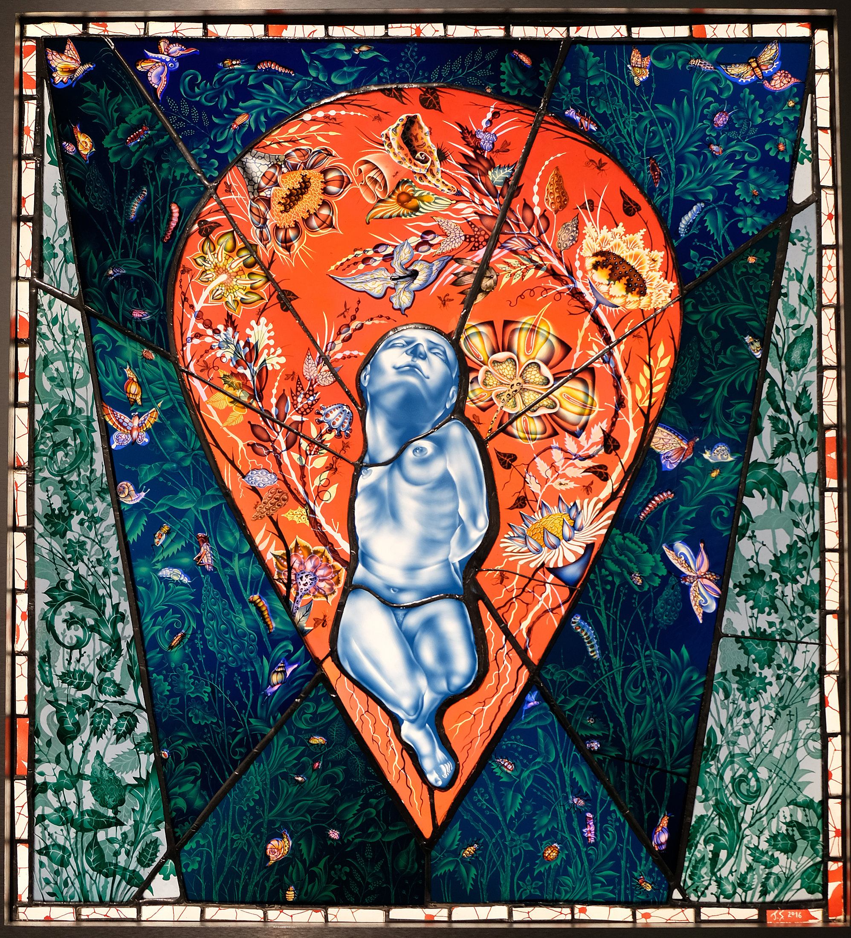
Judith Schaechter, "Life Ecstatic"

GLANC Artist Member News

Lynn-Rachel Altman: "The Secret Garden"; Group Exhibition; Gallery 2727 in Berkeley, CA. March 7 - March 30, 2024. Opening reception on March 7 from 5:30-7:30

Christy Alyosi and Scott Graham: their Sculpture "SLO Bouquet" has become a part of the permanent collection at the San Louis Obispo Botanical Garden

Dean Bensen and Demetra Theofanous: in "By Hand" an International Biennial of Fine Craft at Blue Line Gallery; Roseville, CA; Jan. 20th - March 2nd

Dean Bensen and Demetra Theofanous: received the People's Choice Award in "By Hand", an International Biennical of Fine Craft at Blue Line Gallery; Roseville, CA; Jan. 20th - March 2nd

Dean Bensen and Demetra Theofanous: "Lost Wild", Invitational Group Exhibition; Whitney Modern, Los Gatos, CA ; Feb. 2 - March 30, 2024; Artist reception Feb. 10 from 3-5pm.

Cheryl Derricotte: in "A Two-Way Mirror: Double Consciousness in Contemporary Glass"; VIP opening Oct. 20, 5:30-8pm; Exhibit opens to public Oct. 21, 2023; Museum of Glass; Tacoma, WA

Demetra Theofanous: "Process"; Invitational Exhibition; Art Works Downtown, San Rafael, CA;
Feb. 2- March 23, 2024; Artist reception March 8 from 5-8pm

** Reminder to GLANC Member Artists - help us help you! Submit your artist news by the end of Dec., March, June, and Sept. to have it included in the quarterly newsletter! Submit to glncweebler@gmail.com .
TO BE INCLUDED you must put "Newsletter Artist Member News" in the subject line, and list your name, exhibition/award title, exhibition venue, and dates in your email.

OTHER HAPPENINGS

Fuller Craft Museum: "Material Mapping: Data-driven Sculpture by Adrien Segal & Norwood Viviano; Brockton, MA; May 13, 2023 - Mar. 3, 2024

Museum of Glass Tacoma: "Illuminate - Glass Art for Early Learners"; Museum of Glass; Tacoma, WA; through April 30, 2024

Oklahoma Museum of Art: "Chihuly Then and Now: The Collection at Twenty"; Oklahoma City, OK; through June 23, 2024

San Francisco Museum of Craft and Design: "Neon as Soulcraft"; July 20 - Nov. 24, 2024

OTHER RESOURCES

Please visit these websites to stay up to date on glass events and exhibits both in the Bay Area, and around the country!

• Art Alliance for Contemporary Glass:
www.aacgglass.org
• Bay Area Glass Institute: www.bagi.org
• Bullseye Gallery:
www.bullseyegallery.com
• The Crucible: www.thecrucible.org
• Glass Art Society: www.glassart.org
• Habatat Galleries: www.habatat.com
• Montague Gallery:
www.montaguegallery.com
• Pilchuck Glass School: www.pilchuck.org
• Public Glass: www.publicglass.org

